

Spring  
2022

Vasanthi Pulusu

Bharat Kumar Challakonda

Sabitha Pongadan

Alec Gray

Kimberly Cawi

Mazen Mohamed

Nida Sharief

George Mason University

5/13/2022

**DAEN 690 Project Report**

**Expanding Team Flightify: Predictable VFR Air Traffic Forecasting in all Major Airports in the US**

**This Page Intentionally Left Blank**

Table of Contents

Abstract 9

1 Introduction 10

1.1 Background 10

1.2 Summer 2021 Study 11

1.3 Summer 2021 Assessment 13

1.4 Problem Space 14

**1.4.1** Problem Statement 15

**1.4.2** Problem Focus Areas 15

1.5 Research 16

1.6 Solution Space 17

**1.6.1** Business Solutions 17

**1.6.2** Technical Solutions 17

**1.6.3** Learning Solutions 18

1.7 Project Objectives 18

**1.7.1** Objective 1: Scale- Expanding the number of airports to 500 18

**1.7.2** Objective 2: Accurately predict VFR Traffic in the selected airports 18

**1.7.3** Objective 3: Incorporate findings into visualizations in ArcGIS 19

**1.7.4** Objective 4**:** Develop a Tableau Dashboard to monitor VFR traffic and associated variables 19

1.8 Primary User Stories 19

1.9 Product Vision - Sample scenarios 19

**1.9.1** Scenario One 19

**1.9.2** Scenario Two 20

1.10 Definition of Terms 20

2 Data Acquisition 21

2.1 Overview 21

**2.1.1** Initial selection of 500 airports 21

**2.1.2** Final selection of 500 airports 22

**2.1.3** Other data used in the model 23

2.2 Field Descriptions 25

2.3 Data Context 31

2.4 Data Conditioning 32

2.5 Data Quality Assessment 36

**2.5.1** Data Quality Assessment for the TFMSC dataset 37

**2.5.2** Data Quality Assessment for the TFMSC joint dataset 37

**2.5.3** Data Quality Assessment for the TowerOps dataset 38

**2.5.4** Data Quality Assessment for the NOAA datasets 38

2.6 Other Data Sources 39

3 Analytics and Algorithms 41

3.1 Functional Flow Model 41

3.2 Algorithms 42

**3.2.1** Transform Data frame 43

**3.2.2** Develop Visualizations 43

**3.2.3** Clean Data 44

**3.2.4** Create parametric models 44

3.3 The Path to The Generalized Poisson Regression Model 45

3.4 Forecasting Algorithm 48

3.5 Analyzing the dataset 49

3.6 Deliverables 53

4 Visualizations 54

4.1 ArcGIS Layer of VFR Predictions 54

4.2 Tableau 56

**4.2.1** Main Menu 57

**4.2.2** Executive Summary View 57

**4.2.3** National Map View 60

**4.2.4** VFR Report 61

**4.2.5** Histogram Chart View 62

**4.2.6** Exploratory Findings View 63

**4.2.7** Support View 66

5 Findings 67

6 Challenges 69

6.1 Data Selection 69

**6.1.1** VFR/IFR Data 69

**6.1.2** Weather data 69

**6.1.3** Holidays and Date Components as predictors 70

6.2 Modeling 70

**6.2.1** MLR issues 70

7 Summary 72

7.1 Consul’s Generalized Poisson Regression Model Success 72

7.2 Trends Discovered 72

7.3 Tableau Capabilities 73

8 Future Work 74

8.1 Preprocessing 74

8.2 Model 74

8.3 ArcGIS 75

8.4 Tableau 75

9 Appendix A: Code References 76

9.1 GitHub 76

9.2 Expanding Team Flightify: Predictable VFR Air Traffic Forecasting in All Major Airports in the US 76

9.3 Data Location 76

9.4 Installation 76

**9.4.1** Instructions for acquiring openweathermap free API key code: 76

**9.4.2** Data Cleaner 78

**9.4.3** Model Module 78

**9.4.4** Forecast Module 78

**9.4.5** Tableau Dashboard 79

**9.4.6** Shape File Module 79

9.5 Usage 79

9.6 Credits 79

10 Appendix B: Risk Section 80

10.1 Sprint 1 Risks 80

10.2 Sprint 2 Risks 80

10.3 Sprint 3 Risks 80

10.4 Sprint 4 Risks 81

10.5 Sprint 5 Risks 81

11 Appendix C: Agile Development 82

11.1 Scrum Methodology 82

11.2 Sprint 1 Analysis 82

11.3 Sprint 2 Analysis 82

11.4 Sprint 3 Analysis 83

11.5 Sprint 4 Analysis 83

11.6 Sprint 5 Analysis 83

12 References 84

Table of Figures

Figure 1 Stacked Bar Chart comparing VFR and IFR flight rules for all 8 airports [3] 11

Figure 2 Time series for the 30-day predictions for incoming VFR traffic for each airport [3] 12

Figure 3 Helipad and Helicopter layer in ArcGIS (GLARE) platform 14

Figure 4 FAA The Operations Network>Tower Operations Page in Website 22

Figure 5 Glance of data from Operation Network website 22

Figure 6 Locations of 500 airports by region 23

Figure 7 Glance of data from NOAA weather csv for ABE 24

Figure 8 near_weekend_holiday_dates.csv 25

Figure 9 Gathering filenames from the NOAA and Tower OpsNet directories 32

Figure 10 Preview of the NOAA and Tower OpsNet arrays 32

Figure 11 Airport dictionary creation 33

Figure 12 Snapshot of the airports dictionary 33

Figure 13 Snapshot of the ABE airport 34

Figure 14 Wrangling operations that ingest and house each airports’ datasets 34

Figure 15 FAA airport latitude/longitude coordinate conversion process 35

Figure 16 FAA coordinates and regions are added to respective dataframe 35

Figure 17 Performing column-wise mean-imputation on null values 36

Figure 18 Saving cleaned datasets dictionary to disk using pickle 36

Figure 19 Functional Flow Model 42

Figure 20 Correlation between maximum temperatures and daily VFR traffic for Fairbanks, AK. 43

Figure 21 Actual vs Predicted VFR Traffic 45

Figure 22 Probability distribution and variance and mean functions of the GP-1 model (Sachin Date copyright under CC-BY-NC-SA) [28] 47

Figure 23 The Generalized Poisson Regression Model for Flagstaff Pulliam Field Airport, FLG 47

Figure 24 Distributions of flight by estimated state level hours 49

Figure 25 Flight Hours per state 50

Figure 26 Number of Pilots by State 50

Figure 27 Number of Airports and Aircrafts by State 51

Figure 28 Estimated flight hours by region 51

Figure 29 VFR Traffic by weekdays Teterboro Airport 52

Figure 30 VFR Traffic by weekdays Anchorage Airport 52

Figure 31 VFR Traffic by weekdays Prescott Airport 52

Figure 32 Airports with a point shapefile plotted as a layer in ArcGIS 55

Figure 33 Airports plotted with a circle of approx. 50-mile radius from each airport. 56

Figure 34 The Seven Day VFR Projections for Atlantic City Airport, NJ 56

Figure 35 Consul's Generalized Poisson Regression for ACY: Predicted vs Actual Counts using Test Set 68

Figure 36 Residual Plot vs sqrt PRCP for FAI 71

Figure 37 Average Pseudo R Squared for 9 FAA Regions 72

Figure 38 Screenshot from Open Weather. Subscribe to One Call API 76

Figure 39 Screenshot from Open Weather after clicking Subscribe for One Call API 77

Figure 40 Screenshot from Open Weather. Scroll down to see Pricing Options. 77

Figure 41 Screen shot from Open Weather. Begin sign up. 78

Table of Tables

Table 1 Outlook terms, definitions, and causes 16

Table 2 FAA Regions and States 23

Table 4. Fields in the Traffic Flow Management System Count (TFMSC) Report 25

Table 5 Fields in the Terminal Area Forecast (TAF) Report 28

Table 6 Relevant Fields from the TFMSC report on airports grouped by user class 28

Table 7 Fields in the combined dataset 29

Table 8 Fields in the TowerOps dataset 29

Table 9 Fields in the NOAA weather data 31

Table 10 Future VFR Forecast for ACY Atlantic City International Airport 49

Table 11 ACY Atlantic City International Airport API Pull 49

Table 12 Deliverables to FAA 53

Table 14 Output File for VFR Projections 54

Table 15 List of Airports plotted in ArcGIS 55

Table 13 Airports of Interest, Model, Test Root MSE, Pseudo R Squared 67

# Abstract

Along with the rise in commercial airlines that occupy airspace in the US, there is also an increased number of manned aircraft flying in class G airspace. Some of these aircraft are smaller engine aircraft which follow Visual Flight Rules (VFR), which means they navigate visually, as opposed to Instrument Flight Rules (IFR) which fly by reference to instruments. VFR flights do not have to relay their information to the airport tower before deciding to fly, and as such the Federal Aviation Authority (FAA) does not have a way to predict VFR traffic, which contributes to the safety risk in air and on ground. We explore a new approach to predict the VFR traffic using weather data, date components, day of the week and IFR traffic as variables. A list of 500 airports from 9 different FAA regions in the United States were selected based on the VFR and IFR traffic volume from 2017-2021. For each airport, models including Multiple Linear Regression, Random Forest and Generalized Poisson Regression were used, and the goodness of fit was measured using pseudo R squared value. The Generalized Poisson Regression Model was found to predict the VFR traffic with maximum accuracy. The resultant predictions were then transformed into point and circle shape files with a 50-mile radius to create ArcGIS layers, that are in turn, integrated into the FAA’s internal Geographical Low Altitude Risk Exposure (GLARE) Platform where they can be viewed as part of other existing flight management information. With the proposed model, we aim to enhance the field of VFR traffic prediction, thereby helping the user to better calculate the risks associated with increased air traffic and also providing a reliable way to assign variable human resources to towers and airports when the predicted VFR traffic is high.

# Introduction

## Background

The mission of the Federal Aviation Administration (FAA) states:

“Our continuing mission is to provide the safest, most efficient aerospace system in the world.”

To accomplish this, one of the primary roles is airspace and air traffic management, and a primary objective is safe and efficient use of navigable airspace. [1]

To achieve this objective of safety in the air and on the ground, the FAA mitigates risk in terms of the probability of collisions along these two categories:

1. Static Risk – colliding with inanimate objects such as a building or a tree
2. Dynamic Risk – occurs when 2 flying objects collide into each other

Air risk can potentially create a ground risk. Colliding objects in the air may result in fallen pieces. This poses a risk to people and property on the ground.

Calculating risk requires information about the number of manned aircraft flying in class G airspace using Visual Flight Rules (VFR), roughly 500 feet. Class G airspace is generally used by smaller engine aircraft.

The area of interest in this project encompasses two kinds of flight rules, VFR and Instrument Flight Rules (IFR). The regulations that refer to flying visually refer to VFR. The regulations that refer to flying by reference to instruments refer to IFR. Both terms come from Federal Aviation Regulations (FARs) [2].

Under VFR, the pilots navigate visually, which means they cannot fly in clouds or low visibility conditions. This involves looking out the window to avoid obstacles. As a rule, they need to remain 500 feet below, 1,000 feet above, or 2,000 feet horizontally from all clouds. [2].

IFR pilots fly using in-flight instruments and metrics. They avoid traffic with the use of instruments. IFR aircraft pilots file a flight plan and receive permission (clearance). When VFR aircraft wish to enter certain classes of airspace, they must call for permission. IFR aircraft do not need to call for permission, since they are already flying under direction of an air traffic controller [2].

Every pilot begins and learns flying visual flight rules. An instrument rating opens the opportunity to employ IFR. Then the pilot can fly in poor weather conditions which are prohibited under VFR. An instrument-rated pilot is allowed to fly a VFR flight or an IFR flight, since they are trained in both methods [2].

To enable the FAA to manage risk in the air and on the ground, it is necessary to predict the number of incoming VFR flights. Airports need this information to be able to properly allocate their personnel resources to accommodate the effort associated with processing incoming VFR flights.

However, it is extremely difficult for airports to forecast VFR traffic accurately; therefore, this study focuses on this difficulty as the primary impediment to address. During the summer of 2021 the Data Analytics Engineering team, Team Flightify (1.0), tackled this forecasting problem.

## Summer 2021 Study

This Summer 2021 study created a project with the goal of forecasting ranges of the amount of VFR traffic using historical data provided by the FAA and statistically significant predictors up to 30 days in advance. This would help airport traffic control specialists and operations personnel to prepare adequate resources for the predicted flights. The study was limited to 8 airports: LAS (Las Vegas), TEB (Teterboro), SLC (Salt Lake City), MDW (Chicago Midway), MCO (Orlando), FAI (Fairbanks), AUS (Austin), and AGS (Augusta).

Below is a descriptive data view from the original study of 8 airports. It compares the numbers of VFR flights to IFR flights. While LAS had the most VFR flights, FAI had the highest percentage of VFR flights [3].

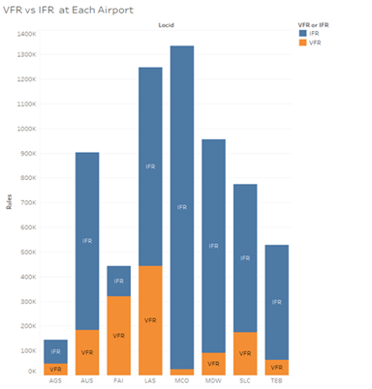

Figure 1 Stacked Bar Chart comparing VFR and IFR flight rules for all 8 airports [3]

As seen in figure 1 from the Summer 2021 study,

”LAS overall has the largest number of VFR flights, with FAI receiving more VFR flights than IFR flights. MCO experiences a low amount of VFR flights at their airport along with TEB and MDW [3].”

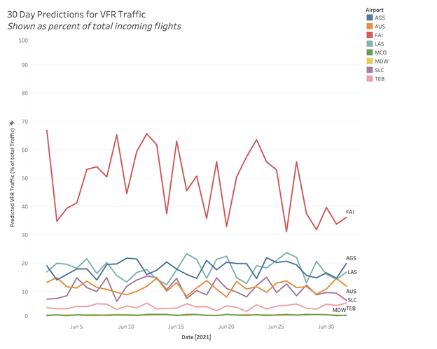

Figure 2 Time series for the 30-day predictions for incoming VFR traffic for each airport [3]

Figure 2 from the Summer 2021 study shows:

“Showcases the initial predictions for each airport for the 30 days after the end of the dataset provided by the FAA. The high variations are expected due to the fluctuating nature of VFR, but the interesting finding is that each airport has a range they fall in. Airports with higher rates of VFR have a wider range, most notably Fairbanks with a broad 30-point range, whereas airports with lower rates of VFR have narrow ranges, such as Chicago Midway with a 2-point range. It’s important to note that this is a short date range compared to previously shown line charts which show five years in one view, so the increased variation is expected with the shorter range of dates rather than smoother trends over time. This timeline is the feature graphic in the Tableau dashboard requested by the FAA [3].”

Findings of the Summer 2021 study, *Assessing the Predictable Behavior of VFR Air Traffic and the Development of a VFR Forecasting Model [3]*:

The Summer 2021 paper consists of a classification problem based on specific attributes of individual airplanes, with a forecast in the appendix. A description of the classification problem follows.

The most successful classification algorithm the prior study produced was Random Forest. It classified VFR traffic to an overall accuracy of 96%. There were small variations for individual airports. Initial findings concluded VFR traffic is less likely than IFR traffic in most of the 8 airports. Alaska was the exception, where VFR traffic was the majority. VFR traffic varies greatly between airports; however, it follows predictable trends within an individual airport. Within an individual airport, VFR traffic falls within specific ranges [3].

Initially, seasonality was used as a proxy variable for weather data, however it did not appear to affect the pattern of VFR traffic. It was of such low importance; it was taken out of the final model described in the main part of the paper. Special events had a low significant impact as well, even though there was always an increase (0.5% - 3%). It was mentioned that special events had been analyzed after completing the model in the Tableau Dashboard and there is an opportunity to explore this further with the possibility of significant findings.

The initial data research prior to the prediction model showed evenings exhibiting the lowest VFR traffic and mid-morning reported the highest. This is expected as morning and afternoon time frames assist with necessary visibility.

In the Summer 2021 study, the most influential feature for classifying VFR traffic was engine type, which correlates to the size of the aircraft. VFR flights were usually flown by smaller aircraft.

## Summer 2021 Assessment

Most of the Summer 2021 paper describes a Random Forest model as the final model used to classify a particular airplane flight as Visual Flight Rules (VFR) or Instrument Flight Rules (IFR). Wording in the paper implies the assumption that this python Random Forest model is the actual forecasting python model fed into the Tableau dashboard forecast; however, it does not appear to be the case.

The Random Forest code we have in hand indeed classifies a particular flight as (VFR) flights or (IFR), but the features used in this model are specific descriptions of the airplane flying, attributes only known after the plane arrives. For example, at time t0 the airport does not know the wing type and engine size of the VFR planes coming in until they arrive, because they are unexpected arrivals. The Random Forest Code we have available is not a forecasting model.

Appendix D and page six of the Summer 2021 paper describe a model where different predictors such as special events, holidays, and seasons were included as predictors. We see no evidence of special events or holidays in the data or the model we received. Seasons were taken out of the final Random Forest Model code that we have in hand, and the main part of the Summer 2021 paper confirms how seasons were taken out of the final model. Another discrepancy to note from the page 20 of the Summer 2021 paper mentions that special events were analyzed after completing the model in the Tableau dashboard. This is inconsistent with the prior description of the dashboard.

We do not have the forecasting code used in the last project. The model code provided cannot be used for the purpose of forecasting the expected Volume of VFR flights thus, Flightify 2.0 assessed that it needed to explore other approaches in collaboration with the partner.

## Problem Space

To better understand the problem space, the team begins by describing the environment in which the FAA operates. Currently the FAA utilizes the Geographical Low Altitude Risk Exposure (GLARE) platform to help assess risk. GLARE is a data visualization tool developed in ArcGIS that renders layers of customized datasets. This platform encompasses many visual layers of information such as Unmanned Aircraft Systems (UAS) sightings, California firefighter information, helipads and helicopters, Automatic Dependent Surveillance – Broadcast (ADS-B) Ground Stations, and Burlington Northern and Santa Fe (BNSF) rail with over 32,000 miles of network.

An example of a risk situation: the country is preparing for air taxis to arrive in the 2025–2026-time frame. They will be flying in a 100–150-mile radius and maybe using the helipad and helicopter locations. How would flying cars affect risk and integrate into the current system? How would it affect airport traffic? Layering VFR predictions over this helipad layer would show an interaction and potential collision risk areas.

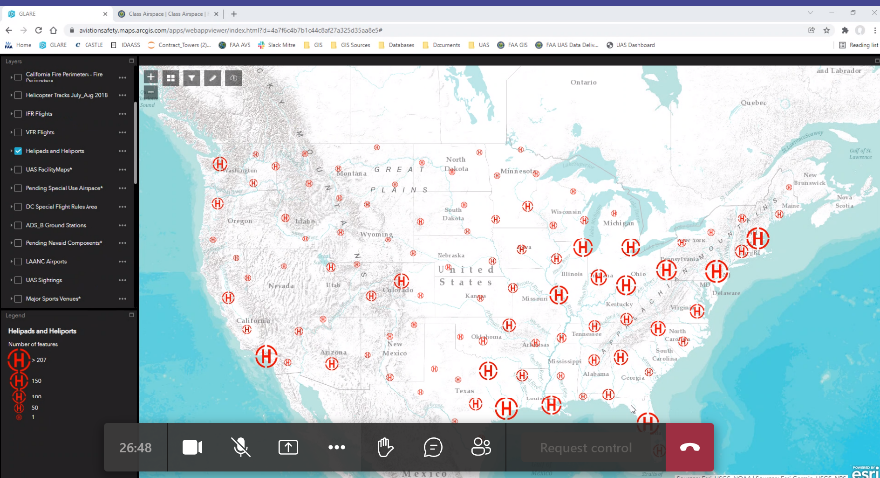

Figure 3 Helipad and Helicopter layer in ArcGIS (GLARE) platform

In September 2021, the National Strategic Planning and Analysis Research Center from Mississippi State University performed a small area estimation (SAE) project to produce estimates for the numbers of manned aircraft flight hours per square mile per year in class G airspace within zip codes. Their deliverables included an ESRI Shapefile which contained elements encoding total flight hours by zip code. Results were provided by type of aircraft and use as well.

The problem space of this project will center around the area of class G airspace and predicting VFR flight behavior with the final goal of producing a forecast, shape file and an interactive Tableau Dashboard.

### Problem Statement

As described earlier, the FAA currently does not have a way to predict VFR traffic which causes safety risks in air and on the ground.

Aircraft using VFR usually are not required to file a flight plan and are not automatically monitored by air traffic control. This requires additional resources to manage their flights which can cause a safety risk when airports are caught unprepared by a large influx of VFR traffic. Therefore, Team Flightify 2.0 designed a model to improve the accuracy of VFR flight predictions in class G airspace, which will enable the FAA to assess risk and allocate proper resources. The partner will be able to integrate the predictions into the FAA Geographical Low Altitude Risk Exposure (GLARE) ArcGIS platform.

### Problem Focus Areas

#### Problem focus area 1: It is difficult to detect locations of high volumes of VFR

Since VFR flight traffic is not relayed in advance to airport towers, there is a need to predict the VFR traffic, as the FAA needs to be able to see where the potential risk is for interaction of VFR traffic with other obstacles in the air and on the ground. After predicting the VFR traffic at each airport, the results of the model are intended for transfer to the partner’s ArcGIS (GLARE) platform. The team delivered a shape file developed in Python with the coordinate system WGS 1984, which the partner can then load into their ArcGIS (GLARE) platform. This shape file, which contains our predictions of VFR aircraft volume per airport, will create a new layer to combine with other layers in the ArcGIS (GLARE) platform thereby helping FAA to better calculate the risks associated with increased air traffic

#### Problem focus area 2: Initial predictions were impacted by noisy data and limited model design

The FAA shared a concern over the predictions in the first Team Flightify study that it may have been difficult to distinguish predictions from noise. The forecast portion of the prior project had limited predictive capability and veered heavily towards exploratory and classification mechanisms. The current team develops different algorithms and forecasting techniques to see if accuracy is improved. Searching for significant predictors will help improve algorithms and forecasting. The plan is to use the historical data using significant predictors appropriate in a forecast scenario to estimate the volume of incoming VFR flights per day for each airport. Improving the quality of predictions will enable the FAA to better assess risk and to be on alert for expected encounters of VFR traffic in certain areas and circumstances.

#### Problem focus area 3: Need for VFR traffic assistance at airports with high VFR/IFR interaction

Air Traffic Control (ATC) offers a service to VFR pilots coming into busy class C or B airports called flight following if personnel resources allow. ATC will assist the pilot with traffic, weather, and avoidance of other aircraft in the airspace. They also help the pilot find routes to avoid heavy traffic. Navigation is still the VFR pilot’s responsibility, but it can be an immense help to the pilot. The VFR pilot does not have to accept the advice if they remain in class E or G airspace [4]

This service is dependent on ATC’s workload and has several layers. If resources are not available, misinformation, misunderstanding, and no awareness of the VFR flight may occur. Flight following is a supplemental tool for seeing and avoiding obstacles, and frequency of congestion at the airport could prevent ATC from giving advisories. The primary job of the controller is separating IFR traffic, not providing VFR advisories. If airports could have accurate predictions of incoming VFR flights, they could increase their resources at those times to increase safety and reduce risk of collisions. [5]

## Research

Prior to every flight, pilots should receive a Standard Briefing, which gathers all information about the nature of the flight [6]. It is designed to assist pilots and aircrews for flight planning and weather forecasting. It contains information on Adverse Conditions, which is significant meteorological information that might influence the pilot to alter or cancel the flight, based on current or forecasted weather that could reduce flight minimums below VFR or IFR conditions. Additionally, the Standard Briefing includes an alert stated as “VFR Flight Not Recommended”. If VFR flight is proposed, and in the Standard Briefing, the sky conditions or visibilities would make flight under VFR risky, the briefing will include a description of the conditions and affected locations, and the alert will be activated. Once the pilot receives the statement, the pilot needs to make a “go or no go” decision. This decision should be based on current and forecasted weather conditions, the pilot's experience and ratings and the aircraft's equipment, capabilities, and limitations. Moreover, pilots flying into areas of minimal VFR weather could encounter some conditions that are not forecasted [7].

Area forecasts, which describes general ceiling and visibility conditions for advanced planning are categorized into four main categorical outlook terms [7]. The definition of those categorical outlooks, as well as their causes are listed in Table 1.

Table 1 Outlook terms, definitions, and causes

|  |  |  |
| --- | --- | --- |
| **Term** | **Definition** | **Cause** |
| LIFR (Low IFR) | Ceiling < 500 ft or visibility < 1 mile | “CIG” (ceiling or visibility restrictions) “WIND” (> 25 knots) |
| IFR | Ceiling 500-1,000 ft or visibility 1-3 miles |
| MVFR (Marginal VFR) | Ceiling 1,000-3,000 ft or visibility 3-5 miles |
| VFR | Ceiling > 3,000 ft and visibility > 5 miles | “WIND” (> 25 knots) |

Pilots flying under VFR have more limitations on when and where they can fly, which require more pre-obtained permissions (or clearances) from air traffic controllers. VFR refers to flying under visual flight rules, which can be as basic as looking out the window and the pilot observing their surroundings while in-flight. Pilots become instrument-rated by obtaining proper training and experience have no limitations on flying and can either fly under VFR or via the use of onboard instruments under IFR [2]. Air Traffic Controllers monitor the safety of aircraft flying under IFR, while pilots flying under VFR are responsible for all things related to the aircraft’s safety.

While piloting aircraft from one location to another under VFR, pilots rely heavily on several measurement tools, instruments, and resources to monitor their positions in the air. This is especially evident in longer cross-country flights. Pilots must strategically plan and plot their course by using aeronautical charts, pre-establishing checkpoints, and measuring distances between points. During flight, they must use this planned course of action while also monitoring fuel, utilizing the aircraft’s built-in compass for directional awareness, and handling external factors such as wind, weather, and other aircraft [6].

While flying a VFR cross-country flight, there are two significant risks involved: Not having a plan is one of the most dangerous aspects of VFR cross-country flight. There are two crucial reasons why somebody should not go out unprepared. The first is the pilot, who is rushing to formulate a plan. That's probably not a substantial deal on a nice day along a well-travelled route. However, launching without a clear notion of what the pilot will do if there is marginal weather, or the risk of marginal weather is very risky. This leads to the second reason pilots go without a plan on a lousy day: they don't have a solid plan, so they go anyhow, hoping to figure something out along the way. On the other hand, the pilot should find things out before the launch. And if the pilot is unable to come up with a sound plan, he should cancel his flight plan. It's genuinely that simple. By learning about the risks, it is clear that the pilot's state of mind also increases VFR flight risk factors. Any aircraft's flying must adjust to some unique characteristics which may compress the baseline safety buffer. So, the typical checklist acronym used to describe risks is PAVE, which consists of Pilot, Aircraft, Environment, and External Pressures.

Many pilots believe that VFR flight is the purest form of flying, and there's a lot to say. On the other hand, it's evident that when there are risk variables involved in the flight, VFR flying poses a significant danger. The risks can be considerably reduced by applying some of the principles of IFR flying to any VFR excursions and by carefully assessing the risk variables, having a plan, and being intelligent and proactive when faced with in-flight hazards.

## Solution Space

### Business Solutions

The project provides insights and predictions on the daily flight volume experienced by VFR and IFR traffic around major national airports to efficiently allocate human resources, to anticipate air and ground risk with a reasonable expectation, and to optimize operations needs for known turbulent weather conditions. The predictions are transformed into point and circle shapefiles which can be used as an additional layer in conjunction with the air traffic data layers used by the FAA in their GIS platform, GLARE.

In addition to this, development of an executive level view and dashboard will provide tools on anticipating flight behaviors, KPI metrics for period of times, and other reporting metrics to provide recommendations to mitigate risk and manage allocated resources to better facilitate decision making. The predictions for VFR behaviors help air traffic management, leadership and personnel in understanding and preparing for outcomes where reliance on visual cues is needed to ensure the safety of passengers, prepare the pilot to change maneuvers, and inform the control center of the changes that are taking place. Forecasting predictions will provide an understanding of what to anticipate and how to optimally prepare for it.

### Technical Solutions

The project developed and deployed a technical solution that predicts and monitors VFR intensity to optimize allocation of resources to better facilitate operation management and executive decision making.

The team's solution composed of a Python code that ingests the data, cleans, manipulates, develops the model, evaluates the accuracy rate, and determines the final model fit to be used for long term. The Python code was then changed into shapefile which can be deployed on the FAA ArcGIS platform GLARE. The development of metrics and charts provided a visual representation of the behavior and calculations needed to determine intensity of VFR, resources associated, and risk observed per selection.

The user interface is comprehensive at any level and access to the tool will be limited to specific FAA personnel. In addition, the solution was also automated to ingest new data while implementing safeguards for long term production and usage. Long term production considerations should include, but not be limited, to monitoring of technical bugs, data discrepancies, data quality checks and many other long term data related issues that may impact the solution.

### Learning Solutions

This project pertains to understanding the development and power that predictive modeling can provide in aviation navigation. Predictions provide a picture to a blank canvas with theoretical ideas supported by iterative statistics, visualizations, and models. The team learned how to select the variables which affect the VFR traffic, data cleaning process, and the models which work best to predict VFR behavior.

The team better understands the importance predictions yield in problems where uncertainty and vagueness permeate. The predictions provide a perspective on outcomes and certainty to an extent where confidence is needed but lacks accuracy. Many groups are involved and need to be informed to support pilots as much as possible if limited communication will occur or turbulent weather conditions are certain.

The team’s product provides a prototype that can be further expanded upon and even improved with new data and techniques being embedded. The team's model provides a method to predict outcomes on flight data that can be further refined with time and provides a foundation on what was done and what could be done. By providing one method to solve a problem, the team has opened the door for more possibilities to be explored. We provide value in approaching this problem by leveraging Poisson distribution modeling techniques using python. In addition, we offer a collective outlook in dissecting this problem from various backgrounds generationally and demographically yet all yielding considerable experience in data science. The value of the solution will be regarded as work developed in 2022 from former students at George Mason University graduates in the Data Analytical Engineering program.

## Project Objectives

The team, in consultation with FAA, recognized and developed four main objectives for the successful completion of the project, which are detailed below with supporting steps.

### Objective 1: Scale- Expanding the number of airports to 500

The initial Flightify project was conducted using eight airports in the United States. Flightify 2.0 plans to develop a code and algorithm that can hold and maintain records for 500 airports which is needed to properly propagate and model the data. The airports will be selected from all nine regions in the United States as designated by the FAA, according to the IFR and VFR traffic volume in those airports. Airports with either only IFR or only VFR will not be selected, as the presence of both IFR and VFR traffic in an airport is necessary to make the project relevant. After the airports are finalized, a data cleaner tool will be developed to clean and format the data from the FAA, merge additional data sources like the weather to the data and perform other data engineering tasks necessary to use the data for machine learning algorithms.

### Objective 2: Accurately predict VFR Traffic in the selected airports

Accurately predicting the VFR traffic for the five hundred selected airports across the US is one of the most important objectives of the project. This requires the development of the most optimal model to make predictions. The Flightify 2.0 team will explore different machine learning algorithms to model VFR counts using the best predictors to forecast the next seven days of VFR traffic. The models will be evaluated for goodness of fit with the appropriate metrics and the best model for each airport will be chosen.

### Objective 3: Incorporate findings into visualizations in ArcGIS

One of the outputs of the model will be a csv file containing the predictions for the VFR traffic for the current day and for the next seven days following that. This file will be converted into a shapefile by integrating latitude and longitude geometry and the coordinate system WGS 1984, which can be incorporated with the GIS platform used by FAA, GLARE, to provide a layer to display and visualize the intensity of VFR trajectories.

### Objective 4**:** Develop a Tableau Dashboard to monitor VFR traffic and associated variables

Using the output from the prediction, an executive level dashboard will be developed in Tableau to report the VFR traffic. The traffic data can be selected according to the date, and airport on a dropdown menu. The dashboard also includes the sunrise/sunset time and other KPIs that make the usage of data easy and relevant.

## Primary User Stories

A few user stories are listed down to illuminate the functionalities performed by the sponsor, FAA and to bring focus on the value provided by the project on those functionalities.

1. As a resource allocator at Chicago Midway Airport, I want to know when to expect large influxes of VFR flight traffic so that I can deploy necessary resources, especially during good weather when we can expect the most flights.
2. As the FAA's partner, I wish to utilize the ESRI shapefile to be able to import it into the ArcGIS platform and assess risk when predicting VFR air traffic, because it will be helpful assessing risk where VFR traffic is more prevalent in airports like LAS and FAI.
3. As a resource allocator at Orlando International Airport, I would like to know how the year, month, day, and day of the week affect IFR and VFR aircraft traffic so that I may deploy resources as needed.
4. As an FAA partner, I was curious to see how events impact the amount of VFR flights compared to a typical day. Having a detailed prognosis of any increase in VFR traffic, as well as a continuous increase in all inbound flights, over the duration of master's week would be beneficial. When anticipating VFR air traffic, I need an ESRI shapefile that I can import into the ArcGIS platform and utilize to assess risk.
5. As an Air traffic controller at Teterboro Airport in New Jersey, I want to know the approximate VFR traffic in my airfield on a sunny Memorial Day weekend to set work schedules.

## Product Vision - Sample scenarios

The everyday scenarios that happen at any airport which necessitates the current project are listed below.

### Scenario One

In Houston, a Southern-central regional aviation manager needs to determine the number of personnel required for the next two weeks, for all the southern-central airports, for morning, afternoon, evening and graveyard shift due to winter holiday incoming and departure airport traffic. Security personnel currently available cannot cover holiday mid-flight security concerns. Using the FAA dashboard, he will select the region he resides in, the associated airports that are linked to it and observe from the daily and weekly metrics the approximate number of VFR traffic, by region, for the next seven days individually and also overall for the week, which consist of 500,000-625,000 VFR traffic.

### Scenario Two

In Florida, in the northern regional federal aviation office, an air traffic control specialist misallocated airplane fuel for nine airports for the next four days because there was a computer glitch that showed fewer flight patterns than anticipated, leading to lower fuel stock levels. The ATC specialist doesn’t have enough fuel for all the flights scheduled and some will need to be rescheduled for another flight or day. Using the Flightify 2.0 application to predict the next four days of VFR flight traffic for his region and those airports, at least 125 flights per day for each airport can be permitted for the next four days until fuel can be restocked again. Neighboring airports have agreed to lend fuel supplies surpassing a week's worth of stock by the third day. The remaining flights will be placed on another flight or rescheduled for another foreseen day.

## Definition of Terms

| **Terms** | **Definitions** |
| --- | --- |
| Instrument meteorological conditions (IMC) | Instrument meteorological conditions (IMC) are a weather category in aviation that requires pilots to fly largely by reference to instruments, and therefore under instrument flight rules (IFR), rather than by external visual cues under visual flight rules (VFR). |
| Instrument Flight Rules (IFR): | Rules that govern flight operations when an aircraft may spend some or all its flight time in IMC and/or when an aircraft will always remain within controlled airspace under radar control. Air traffic control oversees keeping your plane safe from other planes, the ground, and objects (such as radio towers). |
| Visual Flight Rules (VFR): | Rules that govern flight operations when an aircraft spends NONE of its flying time in IMC. The aircraft might be flying in regulated or uncontrolled airspace, with or without radar coverage. Even when the radar is detected, the pilot is responsible for keeping your plane separate from everything else. |

# Data Acquisition

## Overview

FAA Operations & Performance Data provides access to historical traffic counts, forecasts of aviation activity, and delay statistics. Most of the databases contain proprietary information. [7]

The different reports available from the website are Aviation System Performance Metrics (ASPM) report, Operations Network (OPSNET), Count of Operations (CountOps), Traffic Flow Management System Counts (TFMS) report etc.

TFMSC reports provides the air traffic activity at different airports, towers and the radar control facilities associated with the airports, called Terminal Radar Approach Control Facilities (TRACON)s. These are designated by three-digit alpha numeric codes. The CountOps report get their data from National Offload Program (NOP), STARS (Standard Terminal Automation Replacement System), and common ARTS (Automated Radar Terminal System) which is updated daily. The operations network (OPSNET) is the official source of FAA air traffic operations and delay data. Daily Operations Data is available from FY 1990 till the previous day of the date when the report is downloaded.

### Initial selection of 500 airports

There are 19,633 airports in the US currently including private and public, according to the report published by FAA in Aug 2020. To select 500 airports from among them to conduct the project, 2 different datasets from the FAA were used in combination.

Terminal Area Forecast (TAF) is the official forecast of aviation activity in the US. It contains the active airports in the National Plan of Integrated Airport Systems (NPIAS) including FAA-towered airports, Federal contract-towered airports, non-federal towered airports, and non-towered airports. [8] The forecast can be segmented by the users of the national airspace, which are air carriers, air taxi, general aviation and military. The TAF databases for the year 2020 can be downloaded from the FAA website in xlsx format. One of the files in the database lists the details of 3336 airports I the NPIAS system, including their location ID (LocID), city, region etc. This dataset was used as the universe of airports from which to choose 500.

The traffic flow management system counts report (TFMSC) from the FAA website provides the airport view report which can be grouped by airport and user class (e.g., Air carrier, Freight, GA, Military and Other), and by flight type (e.g., (domestic, international). This report provided the list of airports with their location id, segmented by user class and total operations of those user class from the year 2017-2021.Combining this with the TAF airport list provided a list of airports with their location id, city, region and the different user class traffic in the past five years in US.

From that we divided the total airports into regions and selected the top 20% of the airports by General Aviation traffic, combined them and then picked the top 500 airports.

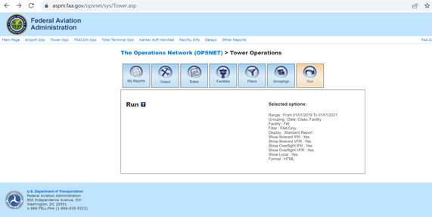

Figure 4 FAA The Operations Network>Tower Operations Page in Website

### Final selection of 500 airports

The TowerOps data provides the number of itinerant (flights which either take off or land in that airport) and overflight (flights which use the airspace to travel from location a to b) data of IFR, VFR and local flights by user class (Air carrier, Air taxi, General Aviation, Military and total). The number of IFR flights is used as one of the independent variables in the model.

Since TowerOps data provided detailed information on VFR and IFR traffic in addition to user class, it was decided to be used for modeling and forecasting instead of the TMFSC report.

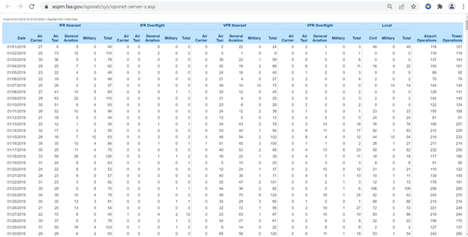

Figure 5 Glance of data from Operation Network website

After comparing the list of selected airports with the corresponding TowerOps report, we learned that 89 of the selected airports did not have corresponding TowerOps reports or had empty reports.

So, we downloaded the TowerOps report from OpsNet for all the available airports in the database, then confirmed the availability of corresponding TowerOps reports to each of the airports in our universe of 3,000 odd airports. All the airports with reports available were taken and then we ran the process again, first grouping the airports by regions, then taking the top 20% of airports of every region by IFR and VFR traffic, and then selecting the top 500 airports from the final list. Thus, a new list of 500 airports was created.

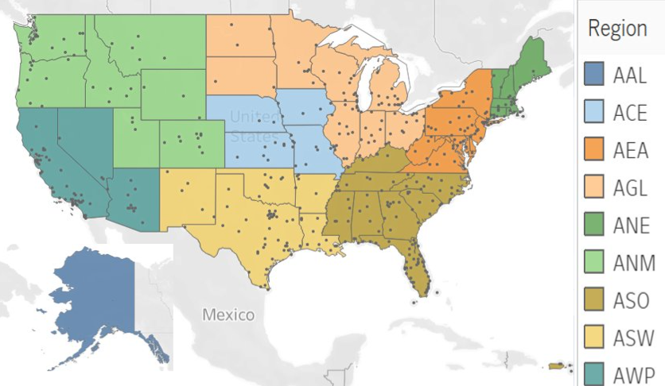

Figure 6 Locations of 500 airports by region

Table 2 FAA Regions and States

| **Region Code** | **Region** | **State Code** | | | | | | | | | |
| --- | --- | --- | --- | --- | --- | --- | --- | --- | --- | --- | --- |
| AAL | Alaskan | AK |  |  |  |  |  |  |  |  |  |
| ACE | Central | IA | KS | MO | NE |  |  |  |  |  |  |
| AEA | Eastern | DE | MD | NJ | NY | PA | VA | WV |  |  |  |
| AGL | Great Lakes | IL | IN | MI | MN | ND | OH | SD | WI |  |  |
| ANE | New England | CT | MA | ME | NH | RI | VT |  |  |  |  |
| ANM | Northwest Mountain | CO | ID | MT | OR | UT | WA | WY |  |  |  |
| ASO | Southern | AL | FL | GA | KY | MS | NC | PR | SC | TN | VI |
| ASW | Southwest | AR | LA | NM | OK | TX |  |  |  |  |  |
| AWP | Western Pacific | AZ | CA | HI | NV | AS | GU | MH |  |  |  |

### Other data used in the model

#### NOAA Weather Data

The National Centers for Environmental Information (NCEI) is the leading authority for environmental data and manages one of the largest archives of atmospheric, coastal, geophysical, and oceanic research in the world. It is the source of archived weather data from NOAA (National Oceanic and Atmospheric Administration).

The weather data can be accessed by weather stations, which are usually at the airports in a particular city. Once a request is submitted at the website <http://www.ncdc.noaa.gov/cdo-web/>, the information is sent to the email address provided at the time of request [9] [10].

The weather data utilized for the project were – Precipitation, Wind Speed, Snow, Minimum Temperature and Maximum Temperature.

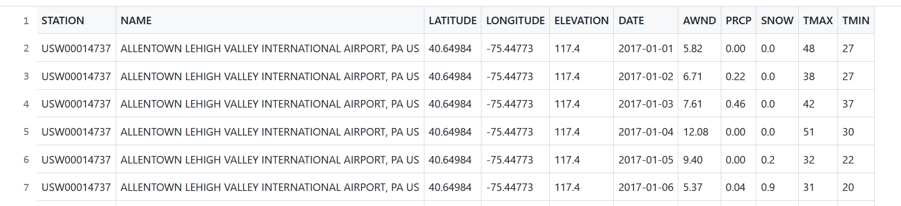

Figure 7 Glance of data from NOAA weather csv for ABE

#### Holidays

Since VFR flights are in the air more on days surrounding holidays and weekends, the list of holidays in the US is taken as a data source. The holiday was initially used as a categorical variable in the Multiple Linear Regression model. For each day of the year, the holiday field answers the question – Is it a holiday – Yes or No, which is modeled as 1 or 0. For the Generalized Poisson Regression Model, the binary variable posed computational difficulties. This is when Day, Month, Year, Day of Week was introduced as predictors which proves more favorable with the matrix algebra aspects of the calculations. Holiday as a binary variable remains for informational purposes and is passed into the Tableau Dashboard. It includes dates surrounding Holidays and Weekends through 12/29/23.

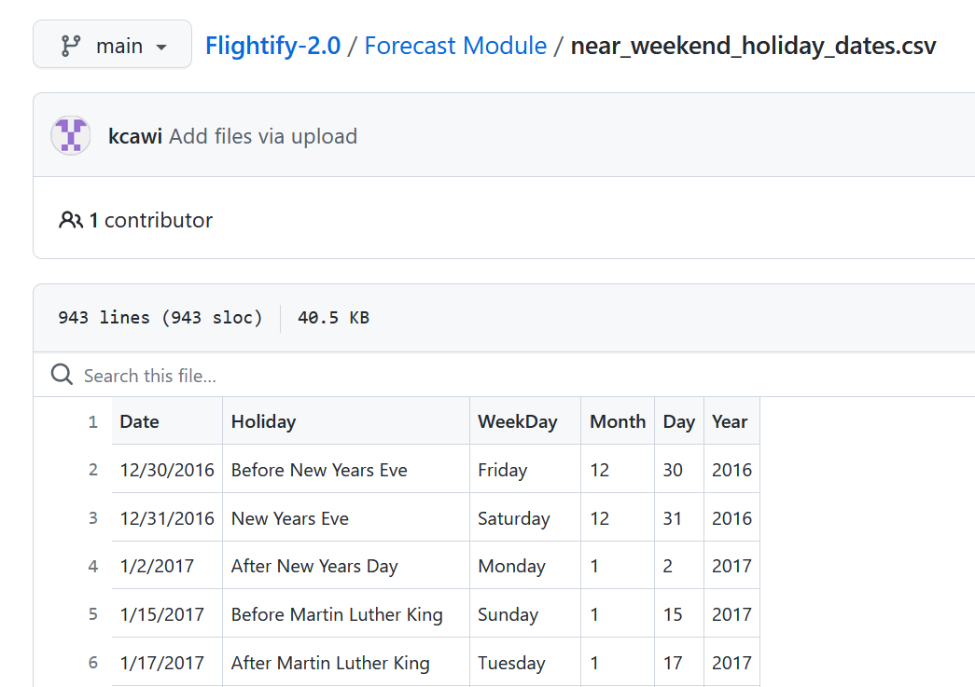

Figure 8 near_weekend_holiday_dates.csv

## Field Descriptions

The Traffic Flow Management System Count report at the FAA website, aspm.faa.gov, provides information on IFR and VFR traffic counts which can be grouped by the type of aircraft, or by hour of day. The fields on this report, the type and description are given below.

Table 4. Fields in the Traffic Flow Management System Count (TFMSC) Report

| **Field** | **Type** | **Description** |
| --- | --- | --- |
| TRACON | Varchar2 | 3-character alpha numeric code describing the radar control facility associated with the airport [11] |
| CALLSIGN | Varchar2 | Group of characters used to identify an aircraft in air ground communications. [12]Generally, it is the aircraft registration number (Tail number). In some cases, FAA assigns callsigns to commercial airliners. Medevac and TV helicopters might be issued separate call signs. |
| LCL_YYYYMMDD | Date | Local Date when flight was counted in the format YYYY-MM-DD |
| LCL_HHMM | Date | Local hour when flight was counted in the format hourhourminuteminute(HHMM) |
| GMT_YYYYMMDD | Date | GMT date when the flight was counted, in the format YYYY-MM-DD |
| GMT_HHMM | Date | GMT hour when the flight was counted, in the format hourhourminuteminute(HHMM) |
| CATEGORY | Number | Four categories of aircraft - Air carrier, Air taxi, General Aviation and Military [13] |
| TYPE | Varchar2 | Aircraft type- Provides the standard abbreviations for aircraft used by ATCs, aircraft operators and automation systems in flight plans. The designator is based upon class, engine number and type, Weight, Wake turbulence category (WTC) etc. (faa.gov document library). [14] |
| RULES | Number | It has categories of flight rules designated as a number. Permissible values: All, IFR, VFR, VPA (VFR Practice Approach), IPA (IFR Practice Approach). |
| LOCID | Varchar2 | Location ID. It is a 3–5-character alpha numeric code to identify aviation related facilities. There are around 28,044 LocID currently designated. [15] |
| BCN | Number | Beacon codes or squawk codes are codes given to an aircraft by the ATC to direct the flight. Squawk codes are four digits, with each being a number between zero and seven. Pilots are required to enter squawk codes into their aircraft transponder to communicate with flight controllers. [16] |
| SCR1 | Varchar2 | Scratchpad 1. - Used to coordinate with other controllers. Also used when clearing an aircraft to a temporary altitude, waypoint or giving a speeding restriction to an aircraft. When it is handed off to another controller, they can see what is in the scratchpad. [17] |
| SCR2 | Varchar2 | Scratchpad 2. Space for controllers to make notes. |
| ADE | Character | Indicates the flight phase - Arrival (A), Departure (D), Enroute/Overflight |
| TWR | Character | Single character field. It is the tower classification. Data entered here if the aircraft is counted for a Tower. A = IFR Itinerant, C = VFR Itinerant, E = Local count (not implemented), F = IFR Overflight, G = VFR Overflight. [18] |
| RDR | Character | Single character field. TRACON classification. Data is entered here if aircraft were counted for TRACON. If an entry exists here, it's recommended to look at the "Rules", "Apt", and "ADE" columns to determine how their aircraft was counted for OPSNET Totals. A: IFR Itinerant Primary; B: IFR Itinerant landing at a hub airport more than 15 miles from another hub airport. C: IFR Itinerant Secondary - airport < 15 miles from the primary or hub; E: IFR Itinerant Secondary - airport >= 15 miles from the primary or hub; G: VFR Itinerant Primary; H: VFR Itinerant landing at a hub airport more than 15 miles from another hub airport; I: VFR Itinerant Secondary - airport < 15 miles from the primary or hub. K: VFR Itinerant Secondary - airport >= 15 miles from the primary or hub. M: IFR Overflight O: VFR Overflight. [18] |
| ENTRY | Varchar2 | Fix is a geographical position determined by visual reference to the surface, by reference to one or more radio NAVAIDs, by celestial plotting, or by another navigational device. Entry fix is the first reporting point, determined by reference to a navigation aid, over which an aircraft passes or is expected to pass upon entering a flight information region or control area. [19] [20] |
| MEXIT | Varchar2 | Exit fix received from NAS fix pairs. |
| RY | Varchar2 | Runway. Runway used for arrival or departure |
| WC | Character | Weight class. a. J – Super AIRBUS A-380-800 (A388) and ANTONOV An-225 (A225)  b. H – Heavy. Aircraft capable of takeoff weights of 300,000 pounds or more   c. L – Large. Aircraft of more than 41,000 pounds, maximum certificated takeoff weight, up to but not including 300,000 pounds.  d. S – Small. Aircraft of 41,000 pounds or less maximum certificated takeoff weight. [21] |
| S1 | Character | Special Designator 1. Special designator 1. Data entered by controller in TRACON or ARTCC and passed to the controller in the Tower. B: RNAV/Heavy, C: Center, E: Enroute, F: B757, H: Heavy, J: Jumbo, L: RNAV/B757, M: RNAV/Jumbo, P: VFR, R: RNAV, V: VFR. [18] |
| S2 | Character | Special designator 2. Overflow of S1. [18] |
| YYYYMM | Date | Local Year and Month |
| HEADING | Varchar2 | True heading of aircraft at time of message. Heading is the direction in which the longitudinal axis of an aircraft is pointed, usually expressed in degrees from North (true, magnetic, compass or grid). [22] |
| CYEAR | Number | Calendar year of operation |
| FYEAR | Number | Federal fiscal year of operation |
| COUNTOPS | Number | 0 = False, 1 = True. Indicates whether this is an official CountOps airport at the time the operation was recorded. |
| QTR | Number | Quarter hour of the operation. Fields are either 1,2,3 or 4. |
| HR_LOC | Number | Local hour of the operation. Goes from 0 to 23. |
| HR_GMT | Number | GMT hour of the operation. Goes from 0 to 23. |
| REPLACEMENT | Number | Replacement Flight. "1" indicates that this record was estimated to account for missing data; "0" indicates that it is actual data. [18] |
| GMT_DATE | Date | GMT date with time |
| LCL_DATE | Date | Local date with time |
| CARRIER | Varchar2 | Aircraft carrier code |

The Terminal Area Forecast (TAF) from the FAA contains the historical and forecast data for aviation activity in the US for the next 2 decades. One of the reports included in the TAF is the airports report, which includes the list of around 3500 airports (as in 2021) with their location data.

Table 5 Fields in the Terminal Area Forecast (TAF) Report

| **Field** | **Type** | **Description** |
| --- | --- | --- |
| LOCID | Varchar2 | Location ID of the airport |
| APORT_NAME | Varchar2 | Name of the airport |
| REGION | Varchar2 | Each airport belongs to one of nine regions, Alaskan, Central, Eastern, Great lakes, New England, Northwest Mountain, Southern, Southwestern, Western Pacific |
| CITY | Varchar2 | Name of city where each airport is situated |
| STATE | Varchar2 | State where airport is located |

The Traffic Flow Management System Count report can be grouped by user class. User class is designation provided by the National Airspace System (NAS) which categorizes airports according to their use, like air carrier, military, general aviation etc. The relevant fields from the report are provided below.

Table 6 Relevant Fields from the TFMSC report on airports grouped by user class

| **Field** | **Type** | **Description** |
| --- | --- | --- |
| Airport | Varchar2 | Name of the airport and location ID |
| User class | Varchar2 | Users of the national airspace, divided into four class, Air carrier, Air taxi, General aviation and Military |
| Departures | Number | Number of departures from the airport |
| Arrivals | Number | Number of arrivals at the airport |
| Total Operations | Number | Total number of operations |

The airport report from Terminal Area Forecast (TAF) and Traffic Flow Management System Count (TFMSC) report was combined to give a dataset with location details of the airport and the user class of the aircraft flying in and out of those airports. The combined dataset has the following fields.

Table 7 Fields in the combined dataset

| **Field** | **Type** | **Description** |
| --- | --- | --- |
| Airport | Varchar2 | Name of the airport |
| User class | Varchar2 | Users of the national airspace, divided into four class, Air carrier, Air taxi, General aviation and Military |
| Departures | Number | Number of departures from the airport |
| Arrivals | Number | Number of arrivals at the airport |
| TotalOps | Number | Total number of operations |
| LocID | Varchar2 | Location ID of the airport |
| Region | Varchar2 | Each airport belongs to one of nine regions, Alaskan, Central, Eastern, Great lakes, New England, Northwest Mountain, Southern, Southwestern, Western Pacific |
| State | Varchar2 | State where airport is located |
| City | Varchar2 | Name of city where each airport is situated |
| LocAirport | Varchar2 | Combined field of location ID and Airport |

The TowerOps data provides the number of itinerant (flights which either take off or land in that airport) and overflight (flights which use the airspace to travel from location a to b) data of IFR, VFR and local flights by user class (Air carrier, Air taxi, General Aviation, Military and total).

Table 8 Fields in the TowerOps dataset

| **Field** | **Subfield** | **Type** | **Description** |
| --- | --- | --- | --- |
| Date |  | Date | Date of Operation |
| a | Air Carrier | Number | Number of air carriers which are IFR itinerant in the airport on the date |
| ab | Air Taxi | Number | Number of air taxis which are IFR itinerant in the airport on the date |
| IFR Itinerant (IFR flights which either take off or land in that airport) | General Aviation | Number | Number of GA which are IFR itinerant in the airport on the date |
| a | Military | Number | Number of military aircraft which are IFR itinerant in the airport on the date |
| a | Total | Number | Total IFR itinerant flights on that day |
| IFR Overflight (IFR flights which use the airspace of the airport to travel from location a to b) | Air Carrier | Number | Number of air carriers which are IFR overflight in the airport on the date |
| a | Air Taxi | Number | Number of air taxis which are IFR overflight in the airport on the date |
| a IFR Overflight (IFR flights which use the airspace of the airport to travel from location a to b) | General Aviation | Number | Number of GA which are IFR overflight in the airport on the date |
| a | Military | Number | Number of military aircraft which are IFR overflight in the airport on the date |
| a | Total | Number | Total IFR overflight flights on that day |
| VFR Itinerant | Air Carrier | Number | Number of air carriers which are VFR itinerant in the airport on the date |
| A | Air Taxi | Number | Number of air taxis which are VFR itinerant in the airport on the date |
| a VFR Itinerant | General Aviation | Number | Number of GA which are VFR itinerant in the airport on the date |
| a | Military | Number | Number of militaries which are VFR itinerant in the airport on the date |
| a | Total | Number | Total VFR itinerant flights on the day |
| VFR Overflight | Air Carrier | Number | Number of air carriers which are IFR overflight in the airport on the date |
| a | Air Taxi | Number | Number of air taxis which are VFR overflight in the airport on the date |
| a VFR Overflight | General Aviation | Number | Number of GA which are VFR overflight in the airport on the date |
| a | Military | Number | Number of military flights which are VFR overflight in the airport on the date |
| a | Total | Number | Total VFR overflight flights on the day |
| Local (Aircrafts which use the airport hangars to park their vehicles) | Civil | Number | Number of civil aircraft which operated from the airport on that day |
| Local (Aircrafts which use the airport hangars to park their vehicles) | Military | Number | Number of military aircraft which operated from the airport on that day |
|  | Local | Number | Total local operations on the date |
| Airport Operations | a | Number | Total IFR itinerant +total VFR itinerant+ Total Local |
| Tower Operations | a | Number | Total IFR itinerant +total IFR overflight+ total VFR itinerant+ total VFR overflight + Total Local |

The National Centers for Environmental Information (NCEI) is the source of archived weather data from NOAA (National Oceanic and Atmospheric Administration). The weather data can be accessed by weather stations, which are usually at the airports in a particular city.

Table 9 Fields in the NOAA weather data

| **Field** | **Type** | **Description** |
| --- | --- | --- |
| Station | Varchar2 | Weather station code |
| Name | Varchar2 | Name of the weather station - Usually city/airport name |
| Date | Date | Date of the report |
| AWIND | Float | Average daily wind speed |
| PRCP | Float | Precipitation |
| SNOW | Float | Snowfall |
| TMIN | Number | Minimum Temperature |
| TMAX | Number | Maximum Temperature |

## Data Context

The FAA datasets used in our study are compiled as objective facts. The information looks at airports and aircraft types based on its use, as well as the flying regulations that are applied. OpsNet Tower Operations Data that is publicly available is used, which comes straight from an FAA automated system that uses data from the National Offload Program (NOP), Standard Terminal Automation Replacement System (STARS) which is used by Air Traffic Controllers to ensure the safe separation of military and civilian aircraft in the US terminal airspace, and Common Automated Radar Terminal System (ARTS), which is an air traffic control computer system to give hourly counts of air traffic activities at TRACONs, towers, and airports. More than 2,000 towers and airports are counted in the data. This information explains the individual accounts of a pilot report that has been filed, as well as the circumstances in which it was filed.

The dataset included the 500 airports that were chosen for the project to offer proof of concept and a foundational model for VFR forecasting. Initially FAA provided data on the eight airports described in the Summer 2021 Study section. Because of the high levels of VFR in these areas, the FAA partners were interested in learning more about them. After finding a FAA data source which was publicly available, the team started working on 500 different airports selected from nine FAA regions to give a wider range within the project, both to scale it and to prevent overweighting confounding variables.

The weather dataset was taken from NOAA which has fields Precipitation, Wind, Snow, Minimum Temperature, and Maximum Temperature. Fog, snow, ice, and crosswinds, for example, require air traffic controllers to widen the spacing between flights landing, decreasing the number of planes that an airport can handle. The same weather can make planes trying to fly between the runway and the terminal building slower and more challenging. The list of holidays in the United States is also used as a data source which acts as categorical variable. For each day of the year, the holiday field answers the question “Is it a holiday” Yes or No, which is modeled as 1 or 0.

In the VFR forecasting modeling, we plan to integrate a weather dataset that describes weather. The weather and holiday data would have a significant influence on the model as well as forecast accuracy. The data is on 500 airports, which is required for appropriate propagation and modeling. All data and computations will be structured for use with the ArcGIS platform, which will include a layer for showing and visualizing the intensity of VFR trajectories.

## Data Conditioning

Data Conditioning is a necessary step for analyzing the data to ensure integrity and usefulness of the data. Several data engineering steps were required to ensure data cleanliness throughout each dataset used in combination for the final dataset for each airport, as detailed below.

Each airport includes data from the Tower OpsNet database, NOAA weather data, FAA’s airport-specific latitude/longitude coordinates, and a source for holidays, which acts as a predictor (whether a date falls on or near a holiday).

The team created a data cleaning program (Data Cleaner 2.0) that processes 1,000 csv files, performs over 40 data engineering operations, and outputs a dictionary that houses 500 prepared and cleaned pandas DataFrames, one for each airport.

Data Cleaner is comprised of two custom modules: airports.py and dataCleaner.py. By leveraging the OS package and two data populated file directories (NOAA.zip and tower_ops_airports.zip), this python script automates the creation of the airport dictionary. The datasets have a naming convention where the first three characters are the airport’s location ID, which the airport dictionary uses to assign the key for each entry. The OS package provides a quick and clean way to carefully ingest into a list the entire contents of a folder at a specified location.

Gathering the files:

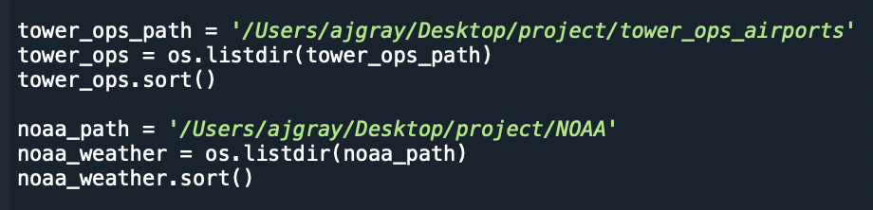

Figure 9 Gathering filenames from the NOAA and Tower OpsNet directories

Outputs the following:



Figure 10 Preview of the NOAA and Tower OpsNet arrays

Because not all airports are available in the NOAA database, several airports share the same weather datasets. The team decided to use nearby NOAA weather stations (within one-two hours) for airports that do not have weather data gathered at their immediate locations. For example, if NOAA does not have weather data for an airport in Manassas, VA, it would be acceptable to use weather data from an airport in Arlington, VA, since, if it’s raining in Arlington, it’s likely to also be raining in Manassas. Airports that initially use duplicate weather data from another airport, must be manually inserted in a separate duplicate airports dictionary for the purpose of renaming the ‘Name’ column of that airport’s NOAA weather dataset to match the correct name for the airport. In the example above, the Manassas airport would need to be put in the duplicate airport dictionary with the correct name of the Manassas airport so that the airport is named correctly.

Once the files have been loaded and the necessary airports have been renamed, the airport dictionary can then assign as dictionary values, the specific csv filenames for each required data source per airport.

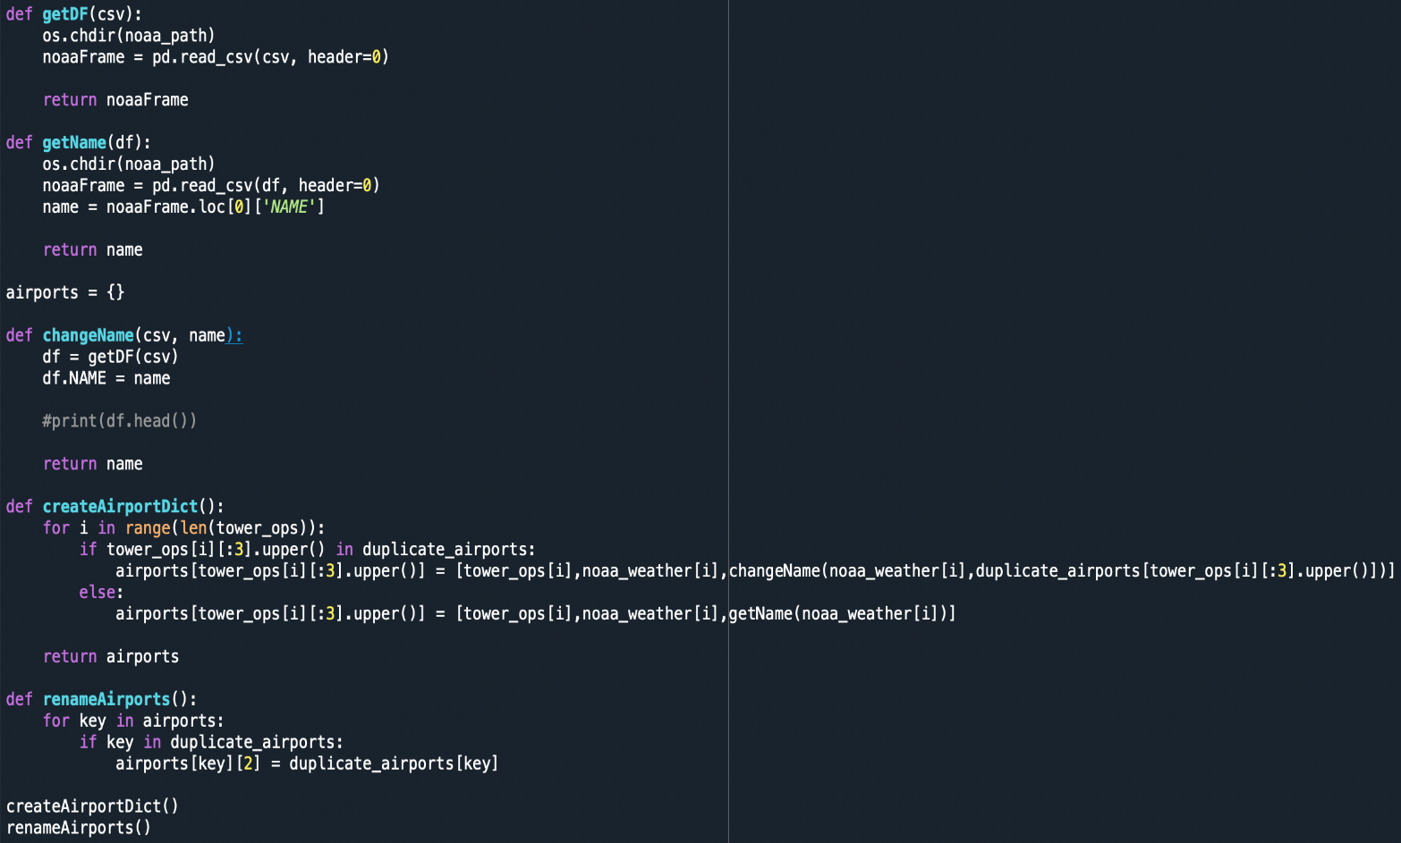

Figure 11 Airport dictionary creation

The airports.py outputs a dictionary with the Location ID as the key and the value, a list of csv filenames along with the accurate name of the airport.

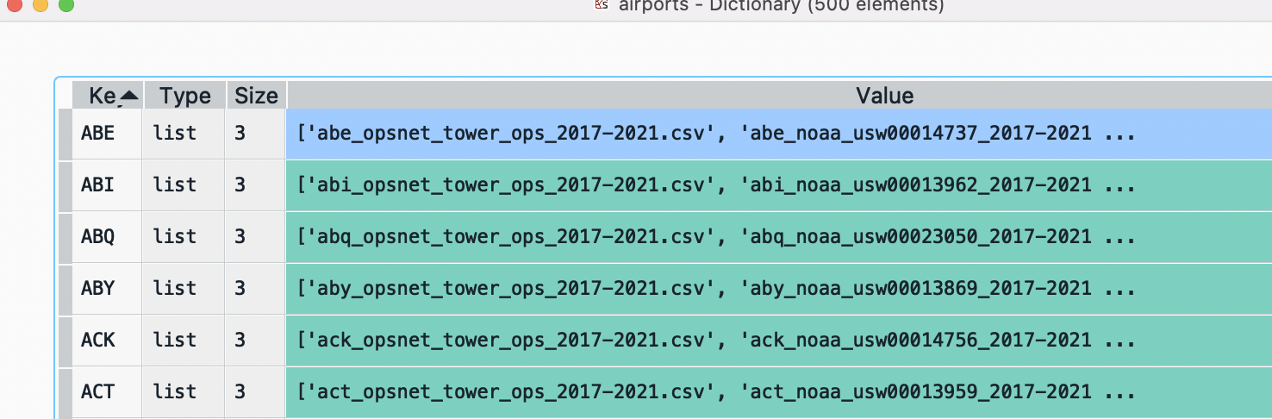

Figure 12 Snapshot of the airports dictionary

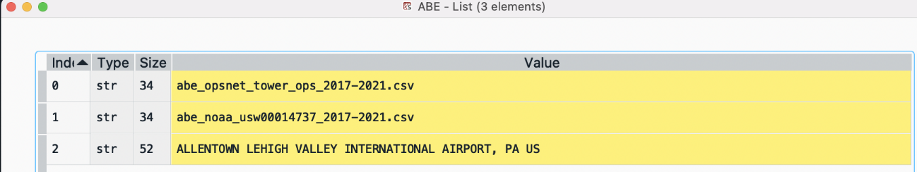

Figure 13 Snapshot of the ABE airport

The dataCleaner.py module serves as the main engine for the data cleaning program. The objective of this program as well as the entire project is automation. Every step needs to be repeatable to prevent duplication and ensure scalability. The dataCleaner.py script starts by using an iterator to ingest the 1,000 csv files provided by the airports.py module and processes them using an advanced read function that looks at two separate file directories and leverages the airports.py module’s duplicate_airports dictionary to ensure airports being read in contain the accurate names. The final step to this initial ingestion process saves the airports’ separate DataFrames as a list value into a list, creating a list of lists object in memory.

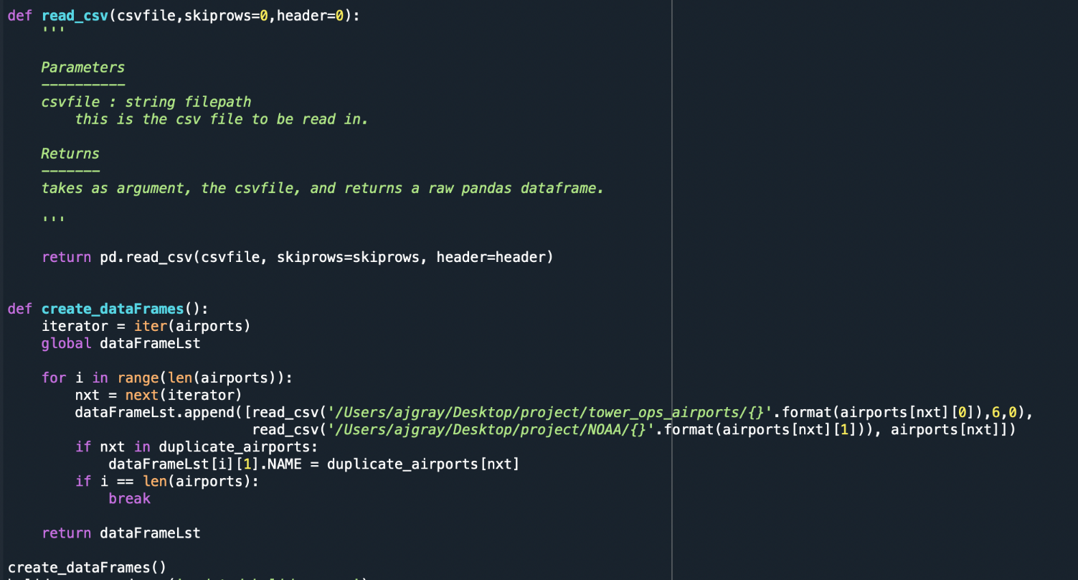

Figure 14 Wrangling operations that ingest and house each airports’ datasets

Initially housing airports’ data in a list of lists provides the ability to iteratively apply specific data wrangling operations to the applicable datasets.

For the FAA Tower OpsNet airport data, the cleaner performs the following steps:

1. Renames the Date column to ensure an easier merge operation with the respective NOAA dataset.
2. Corrects the former string Date column to the appropriate datetime object.
3. Determines if the last column is completely empty and drops it if necessary.
4. Drops the last five rows, which is unnecessary footer data.
5. Correctly relabels IFR, VFR, local, and total columns using a series of complex integrated functions.
6. Removes commas from numerical values, which would otherwise create datatype conversion type issues.
7. Drops the first row of data, which is null

For the NOAA airport data, the cleaner performs the following steps:

1. Convert FAA latitude/longitude coordinates from degrees-minutes-seconds to decimal degrees.

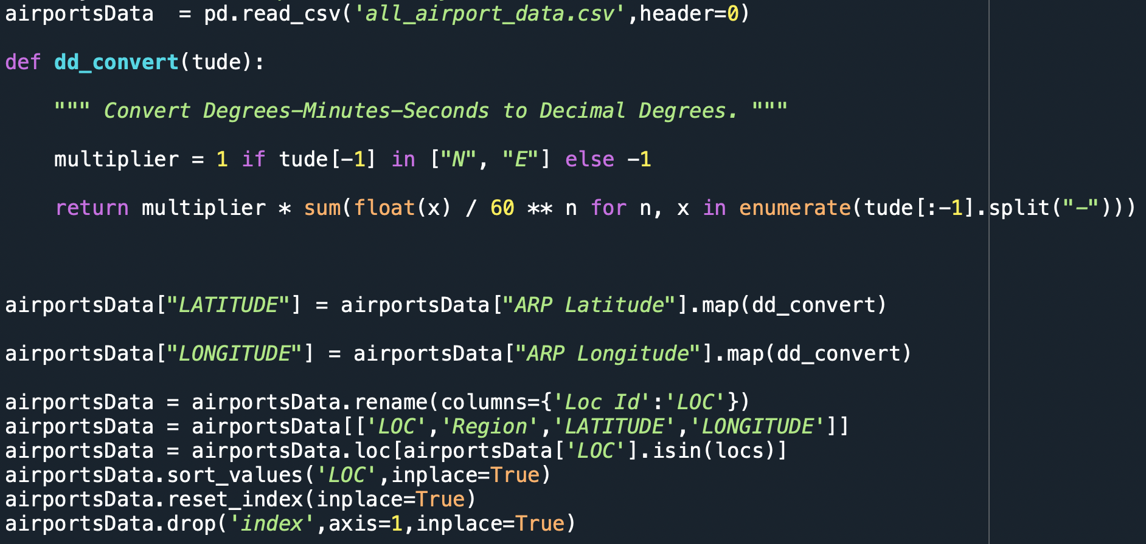

Figure 15 FAA airport latitude/longitude coordinate conversion process

After conversion, the cleaner replaces the original NOAA latitude/longitude coordinates with the more accurate FAA coordinates that are pulled from a separate FAA csv file.

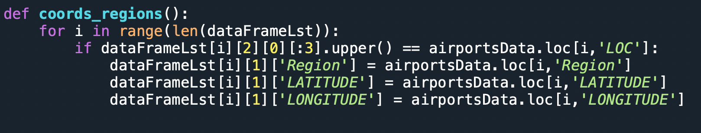

Figure 16 FAA coordinates and regions are added to respective dataframe

1. Converts applicable numerical values to appropriate integer type.
2. Creates the VFR target variable by combining other re-labeled VFR data.
3. Creates precipitation and snow variable transformations.

The data cleaner then merges airport operations (Tower OpsNet) with the corresponding weather data (NOAA) and performs the following steps:

1. Adds the location ID (LOC ID).
2. Adds the holiday predictor, which is 1 if the date is on or around a holiday or 0 otherwise.
3. Adds the region for each airport.
4. Creates the datasets dictionary that houses the merged dataset for each airport with the airport LOC ID as the key.
5. Subsets the desired columns for each merged airport.
6. Finds all columns per merged dataset where data is nonexistent (empty column) and imputes these columns with zeros.
7. Parses out date to capture four additional predictors: year, month, day, weekday
8. Performs column-wise mean imputation for weather data values that are null

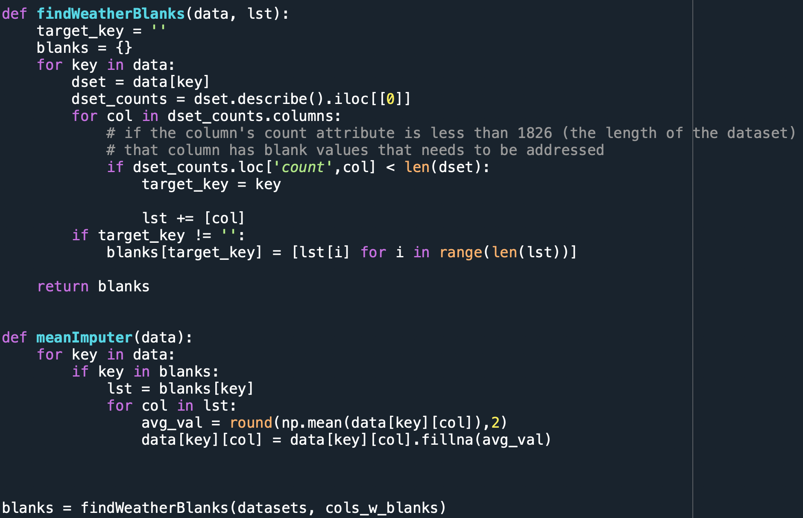

Figure 17 Performing column-wise mean-imputation on null values

Finally, after all data engineering operations are complete, the dataCleaner.py outputs the final collection of cleaned pandas DataFrames as a pickled dictionary.

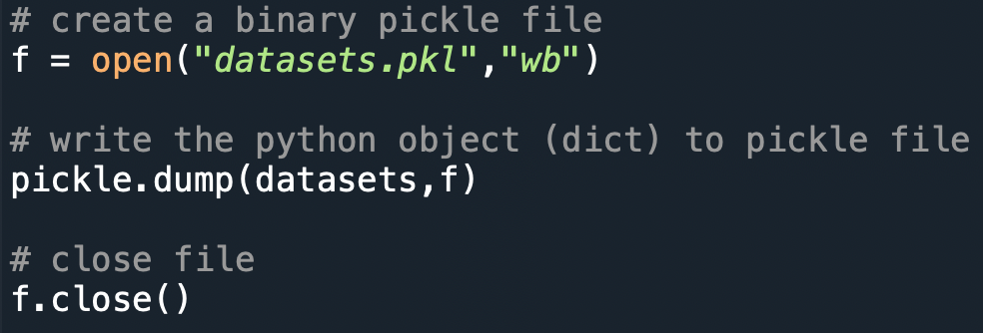

Figure 18 Saving cleaned datasets dictionary to disk using pickle

## Data Quality Assessment

Data Quality Assessment (DQA) can be found by five attributes. In general, the five attributes of the DQA are the following:

1. Completeness of the dataset, which is nothing but the wholeness of the dataset, which states any missing values or gaps in the dataset. The data for the project was sourced from FAA website. For the airports that the team had chosen to work on, the datasets used were complete.
2. The uniqueness of the dataset explains the existence of duplicate values. The data was unique in that the team used the daily IFR/VFR traffic data from FAA. Each entry for the day for an airport was unique.
3. The accuracy of the dataset indicates whether the data reflects reality or not. Since the data was directly sourced from FAA website, the team assumes that the dataset reflects the reality.
4. Atomicity of dataset means that multiple operations can be done in a single grouped entity.
5. The conformity of the dataset means checking whether the data matches the correct standards and rules. For the current project, the conformity refers to the lineage of data, which was either the FAA website at aspm.faa.gov or NOAA which followed the standard conventions of reference of units like latitude, longitude, and weather data used in US.

The data quality assessment of each dataset used in the project are listed below.

### Data Quality Assessment for the TFMSC dataset

This dataset has data about the Traffic Flow Management System Count of Airports from 2017 to 2021.

* Completeness: This Dataset has missing values in some fields like SCR1, SCR2, etc., which does not affect the analysis. So, this dataset has a high level of completeness.
* Uniqueness: This Dataset does not contain any duplicate values. So, this indicates that the dataset, as mentioned earlier, has a high level of Uniqueness.
* Accuracy: This Dataset reflects the reality because FAA provides this dataset. So, this indicates that the dataset has a high level of accuracy.
* Atomicity: The fields present in this dataset are automatically split. So, this indicates that the dataset has a high level of atomicity.
* Conformity: This dataset satisfies the correct standards or rules because the FAA provides it. So, this indicates that the dataset has a high level of conformity.
* Overall Quality: This says the overall quality of the dataset by considering the above five attributes. Considering the above five characteristics for this dataset, we got to know that every attribute has high quality. So, this shows that the dataset has a high level of overall quality.

### Data Quality Assessment for the TFMSC joint dataset

This Dataset has data about TFMS data grouped by User class and TAF data. It is used for selecting the 500 airports.

* Completeness: The datasets are mostly complete with data. There is a small number of airports where a large number of data missing flight data. For these datasets, we are limited to a small number of days/months/years. Some datasets have a few missing rows for a given predictor. For these data, we impute column-wise mean value for missing values.
* Uniqueness: No duplicates exist since data is gathered on a daily basis and the data is unique to that day.
* Accuracy: We can validate the accuracy of our data since it was pulled directly from FAA (the client’s) database.
* Atomicity: The fields present in this dataset are automatically split. So, this shows that the dataset has a high level of atomicity.
* Conformity: This dataset satisfies the correct standards or rules because the FAA provides it. So, this indicates that the dataset has a high level of conformity.
* Overall Quality: The overall quality of the raw data is highly manageable. There are certainly data engineering steps that are required for formatting, predictor transformation, etc., but overall quality is good.

### Data Quality Assessment for the TowerOps dataset

This dataset provides the daily count data, which describe the tower operations of each airport from 2017 to 2021.

* Completeness: The datasets are mostly complete with data. There is a small number of airports where a large number of days are missing flight data. For these datasets, we are limited to a small number of days/months/years. Some datasets have a few missing rows for a given predictor. For these data, we impute column-wise mean value for missing values.
* Uniqueness: No duplicates exist since data is gathered daily and the data is unique to that day.
* Accuracy: We can validate the accuracy of our data since it was pulled directly from the client’s database.
* Atomicity: The fields present in this dataset are automatically split. So, this shows that the dataset has a high level of atomicity.
* Conformity: This dataset satisfies the correct standards or rules because the FAA provides it. So, this indicates that the dataset has a high level of conformity.
* Overall Quality: The overall quality of the raw data is highly manageable. There are certainly data engineering steps that are required for formatting, predictor transformation, etc., but overall quality is good.

### Data Quality Assessment for the NOAA datasets

This data source contains important weather data for each airport from 2017 to 2021

* Completeness: The datasets are mostly complete with data. A small number of datasets are missing three weather predictors, so we are limited to the two or three that remain. Some datasets have a few missing rows for a given predictor. For these data, we impute column-wise mean value for missing values.
* Uniqueness: This dataset has a high level of uniqueness. It does not have any duplicate values because it consists of weather data from 2017 to 2021.
* Accuracy: We can validate the accuracy of our data since it was pulled directly from a nationally accredited and recognized weather data source.
* Atomicity: The fields present in this dataset are automatically split. So, this shows that the dataset has a high level of atomicity.
* Conformity: This dataset satisfies the correct standards or rules because we got this data from NOAA. So, this indicates that the dataset has a high level of conformity.
* Overall Quality: This says the overall quality of the dataset by considering the above five attributes. Considering the above five characteristics for this dataset, we got to know that every attribute has high quality. So, this shows that the dataset has a good overall quality.

## Other Data Sources

A great deal of research was done in search of the original Summer 2021 Flightify data on the FAA website. An inaccessible database, CountOps, was discovered in FAA documentation that described the variables in question in a Detail Report. FAA later provided data for the 8 airports used in the Summer 2021. We discovered VFR and IFR information is available in the public FAA database, OpsNet, in the Tower Operations Report. The team uses the Tower Operations Report instead, because it is publicly available, and no internal pull is required. It saved FAA great effort from downloading extremely large datasets for 500 airports in a piecemeal fashion.

The team investigated ways to access future weather forecasts via python to automate the predictor collection process. Automating the collection of future weather forecast variables means that the partner does not have to assemble 500 seven-day weather forecasts every time the system is utilized to predict VFR traffic. Several sources were explored. The following describes the top contenders.

1. National Oceanic and Atmospheric Administration’s National Weather Service [23]

National Digital Forecast Database (NDFD) Simple Object Access Protocol (SOAP) Web Service

<https://graphical.weather.gov/xml/>

Note:  This works very well as a manual pull.  It matches our attributes for our historical data from NOAA.  The downside is it has sporadic number of days in the forecast. One variable may have four days another six, and others seven or eight. This method was a manual pull not an automatic python pull. We will not be using this source.

1. [National Oceanic and Atmospheric Administration](https://www.noaa.gov/) publishes seven-day weather forecasting data with the API, <https://api.weather.gov/points/> [24]

 Note:  This works for temperature and wind speed. It does not have Precipitation or Snow amounts. It has Sunny, Cloudy, etc. forecast descriptions. The forecast is for about a week. In python, we can pull the forecast and place it into a Pandas data frame. The API, api.weather.gov, is from NOAA. Upon experimentation, reliability of the API is spotty. We are not using this source.

1. <https://python.plainenglish.io/how-to-get-weather-forecast-data-in-your-jupyter-notebook-d93a092d63ec> . This is a good tutorial on how to decipher extract JSON into Pandas data frame. [25]
2. Noaa-sdk python package, SDK, can be used for accessing the NOAA Weather Service REST API for getting recent and forecast data. <https://github.com/paulokuong/noaa> Documentation for the weather.gov API is not very helpful. <https://www.weather.gov/documentation/services-web-api>  Note: No documentation for the JSON response. Not sure of accuracy of the pull from the API.
3. PyNDFD is an open-source Python module that retrieves forecast data from the US National Weather Service (NWS) - National Digital Forecasting Database (NDFD). [26] <https://github.com/marty-sullivan/pyndfd>

Note:  Looks promising but there was trouble building pygrib during install. Since data is from National Digital Forecasting Database (NDFD), the variables will probably vary in forecast length. The team is not using this source.

1. Tomorrow Python Weather API

<https://www.tomorrow.io/blog/creating-daily-forecasts-with-a-python-weather-api/>

Note:  Promising but charges for level we need. If running 500 airports, we will need to be able to do more than 25 calls per hour.  We are not using this source.

1. Open Weather Mobile App [27]

Data Sources: NOAA, Met Office, European Centre for Medium-Range Weather Forecasts (ECMWF), Environmental Canada <https://openweathermap.org/>

<https://openweathermap.org/api/one-call-api>

Note: This is a good version of a weather API. We can get a seven-day forecast for free, 1,000 calls a minute and 30,000 calls/month. Response is in JSON for the free version. This source has the attributes that are need and it proved consistent and reliable. Documentation is extensive and the most thorough so far. We are utilizing this source for the forecast.

# Analytics and Algorithms

## Functional Flow Model

The Functional Flow Model (Figure 19), shows the functional flow of the system’s modules, data input, and data output.

The first phase describes Airport Selection. Two data sets, the TAF database and the TFMS database combine in the airport selection module. The procedure chooses the top 20% of airports by VFR traffic from each region, making sure that each airport also has a high volume of IFR traffic. From the final list the team chooses the top 500 airports with the most VFR traffic. These are the 500 airports for the model.

The next phase is the Model Building. For each airport an OpsNet TowerOps report and NOAA weather information is downloaded. FAA latitude and longitude is also downloaded. The team provides a Holiday list for the module. The Cleaning Tool combines the necessary data and creates a data set. It takes care of unnecessary labeling, headers, footers, and text. It reformats data, relabels columns, and performs data type conversion. The Cleaning tool also calculates variables, such as Holiday. The output is a cleaned, combined DataFrame for every airport. The Model building module receives the cleaned dataframe for individual airports. The appropriate model type for each airport is run automatically choosing significant predictors. Then an updated Model Dictionary with model results is exported to disk.

The Forecasting Phase brings in the Model Dictionary and a current plus seven-day weather forecast data as inputs. The weather forecast is actually pulled using python code within the Forecast Module. It accesses the Open Weather API and receives a JSON response. From the JSON response, specific forecast information is extracted and placed into a new Pandas DataFrame. Predictions are calculated in the Forecasting Module and combined forecast results including statistical information for all airports is saved as a csv to disk. A specific shape file csv with forecast results is also saved to disk. These csv’s feed a Tableau Dashboard and Shape File Module. The Shape File Module creates a shape file for a layer of VFR predicted counts for the ArcGIS (GLARE) platform. The Tableau Dashboard displays the VFR forecasts and other necessary reports.

The final layer is for the Partner to utilize the Shape file to create and display the ArcGIS layer for the (GLARE) platform.

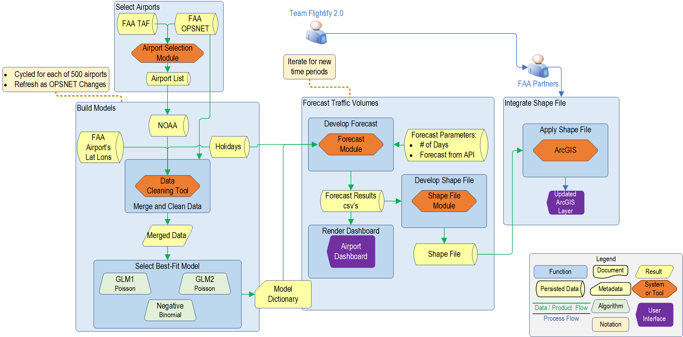

Figure 19 Functional Flow Model

## Algorithms

A data cleaner tool was created to clean, preprocess, merge, and design all NOAA weather and FAA OPSNET Tower Operations air traffic datasets for 500 airports. The python tool uses pandas to remove extraneous headers and footer text, perform data type conversion on applicable variables, create additional numerical and categorical variables, integrate airport location and holiday classifiers, and more. The tool is configured to handle 500 different airports and will output a csv file with the cleaned, prepared, and preprocessed data, ready for algorithmic modeling. This tool is the foundation for each airport’s predictive model.

The scatterplot below shows the correlation between maximum temperatures and daily VFR traffic for Fairbanks, AK.

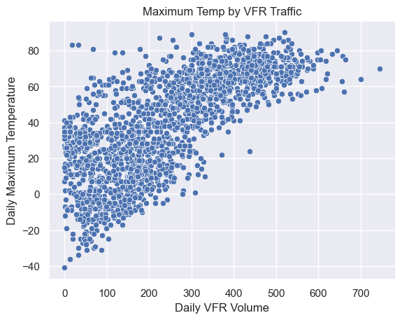

Figure 20 Correlation between maximum temperatures and daily VFR traffic for Fairbanks, AK.

When developing the algorithms necessary to create predictive models, we must first preprocess the FAA dataset to be manipulated. Using Python as the programming language, the following preprocessing packages, though not limited, will be used:

### Transform Data frame

The data used for the final modeling was first sourced from different sources, and then transformed into a dataframe fit to apply for modeling and machine learning algorithms. These packages were used in Python for preprocessing and transforming the data.

1. NumPy – Used to perform multi-dimensional array computing, vectorization and indexing on the dataset
2. Pandas – Used to manipulate the data frame (concatenating, merging, dropping, duplicating columns and rows) in addition to variables that are numerical, text, date type variable etc.
3. OS – Used to create and remove directory, fetching the contents of the directory etc.

### Develop Visualizations

Good visualizations are an important tool in communicating to the user about the findings in data in a concise and powerful way. The following packages were used in visualizations.

1. Matplotlib - Develop visualization like graph, charts, distribution plots to determine outliers and data irregularities
2. Seaborn – Similar to Matplotlib, creates visualization and charts
3. Tabulate – Create tables with number formatting and column alignment

### Clean Data

Data Cleaner is comprised of two custom modules: airports.py and dataCleaner.py. By leveraging the OS package and two data populated file directories, this python script automates the creation of the airport dictionary.

1. Airports.py - Automates the creation of our airports dictionary by ingesting 1,000 csv filenames from two data-populated file directories.
2. Data cleaner- imports the airports dictionary form the airports.py module and performs a myriad of data engineering/data wrangling operations. For each airport, the data cleaner replaces missing values, encodes categorical variables, drops rows with missing values, performs column-wise mean imputation, removes unnecessary header/footer text, creates variable transformations, relabels variables, drops columns that are completely empty, iteratively performs joins with another FAA dataset in order to grab the FAA lat/long coordinates, determines which dates are during/or around a holiday in order to create a Holiday predictor, and other data wrangling steps.

### Create parametric models

The following packages and models were attempted or selected.

1. Scikit-learn (attempted) – This package was used to create the following predictive models that all failed to accurately predict VFR counts.

* Monte-Carlo
* Linear Regression (w/o time lags)
* Multiple Linear Regression
* Random Forest
* Elastic Net

1. Statsmodels - The Generalized Linear Modeling (GLM) approach proved extremely useful in accurately predicting VFR traffic. The following GLM models were either attempted or used in the final model dictionary construction:
   * Poisson - attempted
   * Negative Binomial - selected
   * Gamma - attempted
   * Generalized Poisson (level 1) - selected
   * Generalized Poisson (level 2) - selected

The model below is an initial first look at our GLM Generalized Poisson model for ACY. This model has been scaled for 497 airports.

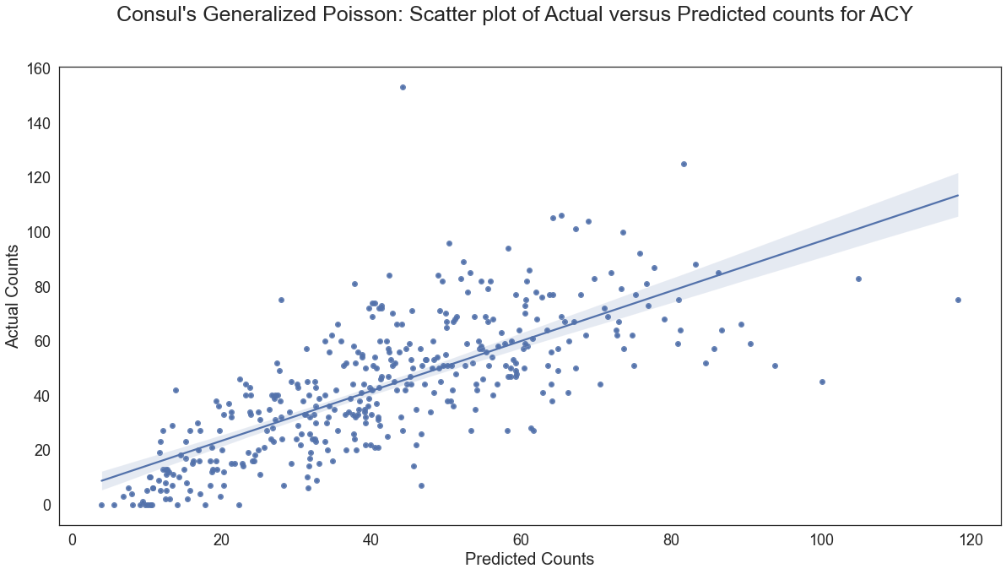

Figure 21 Actual vs Predicted VFR Traffic

## The Path to The Generalized Poisson Regression Model

The partner initially suggested using a Monte Carlo method to predict VFR flights. This seemed like a very interesting idea at the time. VFR flight predictions could be adjusted and updated as new historical data became available. To implement, hundreds of probability distributions would need to be crafted and the selection of these distributions would be based on general assumptions. Then data would be simulated. With so many estimates and assumptions, the possibility of model accuracy appeared to be very low and complexity very high.

A different approach was needed. Since we already had high quality and several years of data from the FAA, the approach of using the historical data and finding what causes the patterns to deviate from the average seemed to be a more direct and potentially more accurate approach.

The problem remained of identifying good predictors. This was a challenging aspect of the project. Many ideas came to mind from the team and partners.

Predictors need to be indicators of a pilot’s decision of whether they are going to get into the plane and fly that day or choose to stay on the ground. This decision is influenced by a multitude of environmental and personal factors.

The predictors must have the following requirements:

* Every predictor needs to be able to be estimated for future days. The team needs to keep in mind that just because we may have historical information for a predictor, it does not mean we have future information for the same predictor.
* Every predictor needs to have potential variance to some degree by day within a specific airport. Since we are creating a separate model for each airport, variability of the predictor among days is necessary or the predictor is not useful.

An early attempt with a multiple linear regression algorithm predicted VFR flights in a range of negative infinity to infinity. This did not fit the distribution of our VFR flight counts at all. It caused excessive errors, dipping VFR predictions into substantially negative numbers. Another approach was necessary. Random Forest was explored, but also resulted in poor accuracy.

The VFR dependent variable consists of integer counts in the range of 0 to infinity. A Poisson Regression model comes to mind for modeling counts-based data. However, the Poisson distribution assumes that the mean and variance of the dependent variable are equal. This is usually not the case in real world datasets. The counts are not often equi-dispersed.

When the variance of y is greater than what the model expects, the dataset is over-dispersed. When the variance of y is less than what the model expects, the dataset is under-dispersed. When this occurs, the model is unable to explain the variability of the VFR counts, and the predictions will not be accurate [28].

To fix this problem, we can assume that the variance is a function of the mean by introducing a dispersion parameter. This dispersion parameter accounts for the unknown variables that cause the variance in y to be different than what the model is expecting [28].

There are several possibilities for generalizing the Poisson Regression Model. We found the Consul’s Generalized Poisson Regression Model to be the most beneficial for all airports except one, AEX, where the Negative Binomial Regression model was utilized.

In 1989, Prem C. Consul modified the Poisson distribution to handle both over-dispersed and under-dispersed data. The model is called the Generalized Posisson-1 (GP-1) model. The y variable, the VFR flight counts, is assumed to have the following probability distribution seen in Figure 22 Probability distribution and variance and mean functions of the GP-1 model (Sachin Date copyright under CC-BY-NC-SA). Note when alpha, the dispersion parameter, is set to 0, the formulas revert to the standard Poisson distribution [28].

The coefficients (beta values) are calculated by maximizing the Log Likelihood Function.

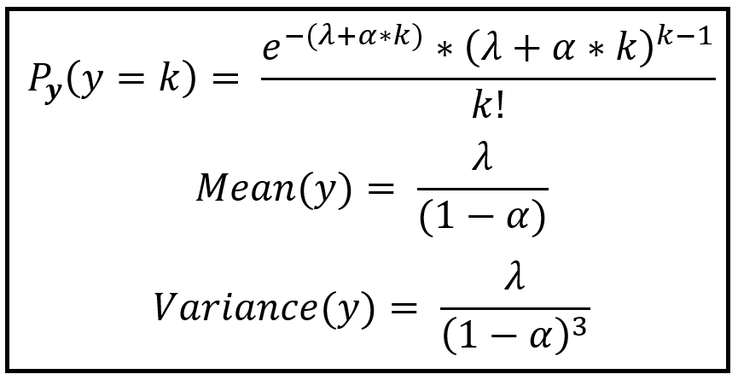

Figure 22 Probability distribution and variance and mean functions of the GP-1 model (Sachin Date copyright under CC-BY-NC-SA) [28]

Now we move forward along the Functional Flow Model. Clean, merged data from the Data Cleaning tool feeds into the Model Module. The Generalized Poisson Regression models, Generalized Posisson-1 (GP-1) and Generalized Posisson-2 (GP-2), and Negative Binomial were initially reviewed among airports and the best model was chosen. As mentioned above, the choice for all but one airport is the Consul’s Generalized Poisson Regression Model. AEX uses the Negative Binomial Regression Model. These models automatically choose predictors chosen from a list of possibilities of weather variables: Wind Speed, Precipitation, Snow, Maximum Temperature and Minimum Temperature. Non-weather predictors include IFR, Month, Day, Day of Week, and Year. Final selection of predictors is chosen through iterative model runs based on p-values less than .05.

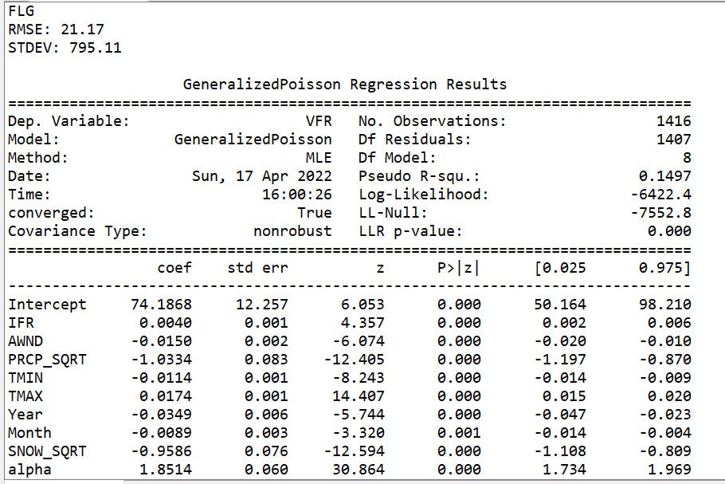

Figure 23 The Generalized Poisson Regression Model for Flagstaff Pulliam Field Airport, FLG

We can see in the above figure, The Generalized Poisson Regression Model for Flagstaff Pulliam Field Airport, FLG, the predictors chosen in the left column including the dispersion parameter, alpha. The following columns show the coefficients (beta values), standard errors of the coefficients, z statistic, p-values, and 95% confidence intervals for the coefficients.

The goodness of fit for the GP-1 model is determined by examining the Log-Likelihood which represents the model with the displayed predictors and the LL-Null value which represents the Log Likelihood for the Null Model (intercept only model) [28]. We want to see the Log-Likelihood value, -6422.4, greater than the LL-Null value, -7552.8, and it is.

The LLR p-value helps determine if the difference between the Log-Likelihood and LL-Null values is significant [28]. The value here is 0.000, which is <.05, so it appears the current model is doing a better job of modeling than an intercept only model.

The pseudo R-squared, .1497, is a different number than we usually see in ordinary least squares regression. This is computed as 1 – (Log-Likelihood/LL-Null). Larger values are desired. A value of 0.2-0.4 is ideal.

## Forecasting Algorithm

The Forecast Module is the predictive powerhouse of the system. Features chosen in the training set must be transferable to a forecast setting. Many predictors were suggested in the model design stage that seemed like a great idea at the time but were not conducive to forecasting. If future values are not attainable or estimable at the time of forecast, they can’t be used in the training or the forecast model. We need access to all features for the forecasted future dates at the time t0, which is the current day the user is running the forecast. This was a challenge regarding finding a source that provided as complete information as possible for all our predictors, for all of the necessary forecast days, in as many of the 500 airports as possible. The second challenge was finding a way to automate the process, so the user of the system did not have to create a dataset of predictors for 500 airports by hand for the number of forecasting days. This was accomplished by pulling forecast information from the Open Weather API, receiving a JSON response, extracting the predictors of interest, and placing them into a pandas Data Frame.

Using the Forecast Data Frame created from the Open Weather API forecast and extracted information from the saved Model Dictionary, the system predicts the current day plus the next seven days of VFR traffic. The module iterates through the airports and creates a combined csv of VFR predictions along with statistics for every airport to feed the Tableau Dashboard. It also creates a shape file csv to feed into the shape file module.

Below we see an example of the current plus seven-day forecast for ACY, Atlantic City International Airport.

Table 10 Future VFR Forecast for ACY Atlantic City International Airport

| **Day** | **VFR Forecast** |
| --- | --- |
| Current | 23.80 |
| Day 1 | 11.28 |
| Day 2 | 21.24 |
| Day 3 | 39.22 |
| Day 4 | 37.18 |
| Day 5 | 42.55 |
| Day 6 | 19.43 |
| Day 7 | 29.66 |

The table below is a snapshot of part of the pull from the Open Weather API for Atlantic City International Airport, ACY. This is a section of the Data Frame created after extracting information from the JSON response of the API. Data was converted to the necessary units to match the historical data units.

Table 11 ACY Atlantic City International Airport API Pull

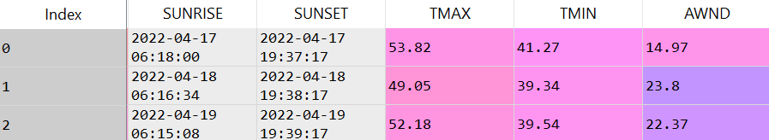

## Analyzing the dataset

FAA estimated state level hours plot was developed to display the distributions of flight by state using pandas to manipulate and merge data files, and seaborn to generate the distribution plot. The plot shows a normal distribution development near the 0 – 1,000,000 hours and outliers near hours exceeding 2,000,000 – 2.5,000,000. We should anticipate normal hours ranging within the 0 – 1,000,000 hours.

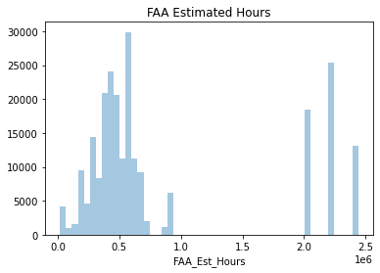

Figure 24 Distributions of flight by estimated state level hours

The total estimated flight hours are displayed by state and from the bar plot, California, Texas and Florida show the highest accumulated flight hours. We should anticipate many aircrafts, pilots near airports near these states.

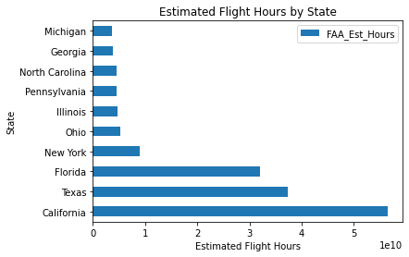

Figure 25 Flight Hours per state

As mentioned previously, the largest number of pilots by state is predominantly in California, Texas and Florida once more. The same can be said for the number of aircrafts and airports to accommodate large flight hours endured.

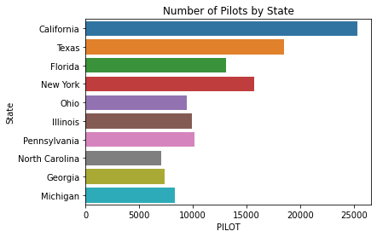

Figure 26 Number of Pilots by State

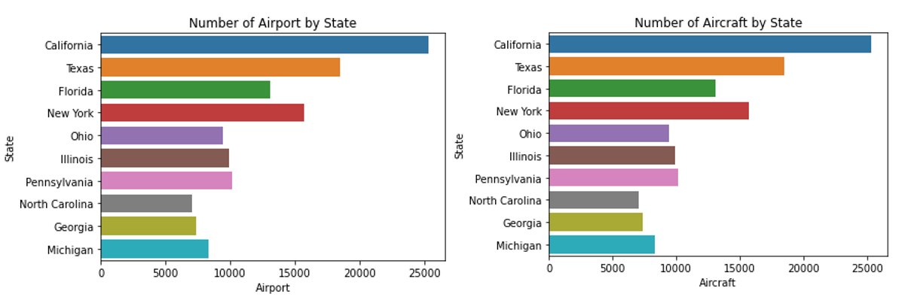

Figure 27 Number of Airports and Aircrafts by State

From merging the GA Survey with the Census data, the following bar plot was developed to display the Region by estimated flight hours. The plot displays Western Pacific and Southern-western areas have the most hours. The highest flight hours align with the previous bar chart that specified California and Texas having the largest accumulated hours.

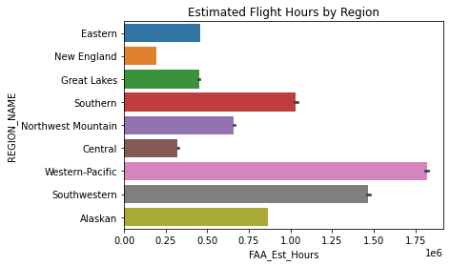

Figure 28 Estimated flight hours by region

Analysis of 3 random airports for VFR Traffic by weekdays

To find the distribution of VFR traffic across the airports by day, we plotted the box plot of VFR traffic for each airport against the weekdays. The plots show us that there is no pattern in traffic which is common for all airports. Each airport has its own pattern of VFR traffic for each weekday.

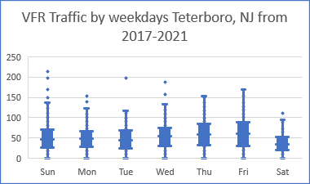

Figure 29 VFR Traffic by weekdays Teterboro Airport

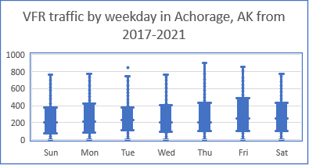

Figure 30 VFR Traffic by weekdays Anchorage Airport

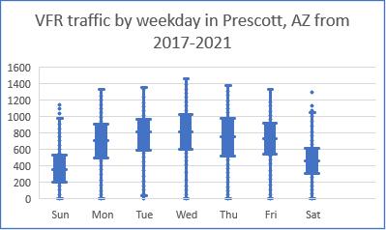

Figure 31 VFR Traffic by weekdays Prescott Airport

## Deliverables

The results of the model will help the FAA allocate their resources to mitigate accidents in the air and on the ground.

Table 12 Deliverables to FAA

| **Deliverable** | **Description** |
| --- | --- |
| Showcase Presentation and PowerPoint Insights | A final showcase presentation where the team describes the project in detail will be held and the PowerPoint slides shared. |
| Final Project Report | The detailed report of the project will be made available. |
| GitHub Repository for data and code artifacts | The entire datasets, the codes and the Readme file will be available at the GitHub repository and the information shared with FAA. |
| Two ESRI Shapefiles | The shapefiles will be developed in Python with WGS 84 coordinate system. There will be one point shapefile and a circle shape file with 50-mile buffer. |
| Visualization encompassing the ArcGIS platform | The team will map the shapefiles as a layer in ArcGIS Pro to make sure it works as planned and the visualization will be presented in showcase. |
| List of airports with associated model descriptions | List of airports with associated model descriptions including Intercept coefficients and its standard error. Histogram and descriptive characteristics of range of intercepts will also be delivered. |
| Tableau dashboard to report VFR predictions and requested Reports | An interactive Tableau Dashboard and executive level view will also be produced so that the sponsor will have the relevant VFR data by region, state or airport. |

# Visualizations

## ArcGIS Layer of VFR Predictions

Once the VFR predictions for each airport is completed, the next task is to change each file into a point shape file and a circle shapefile so that it can be added as a layer onto a mapping software used by FAA, GLARE.

The output file containing the VFR predictions has the following columns: Location code of airport, latitude, longitude, VFRday0, VFRDay1, VFRDay2, VFRDay3, VFRDay4, VFRDay5, VFRDay6, VFRDay7.

Table 14 Output File for VFR Projections

| LOC | LATITUDE | LONGITUDE | Date  Of  Day 0 | VFR  Day  0 | VFR  Day  1 | VFR Day  2 | VFR  Day  3 | VFR  Day  4 | VFR  Day  5 | VFR  Day  6 | VFR  Day  7 |
| --- | --- | --- | --- | --- | --- | --- | --- | --- | --- | --- | --- |
| JFK | 40.63915 | -73.7639 | 4-3-22 | 33 | 64 | 31 | 21 | 28 | 65 | 53 | 51 |
| EWR | 40.68275 | -74.16927 | 4-3-22 | 118 | 214 | 98 | 76 | 91 | 215 | 145 | 174 |
| LGA | 40.77945 | -73.88027 | 4-3-22 | 67 | 168 | 69 | 41 | 60 | 169 | 114 | 116 |
| TEB | 40.85898 | -74.05616 | 4-3-22 | 36 | 60 | 34 | 27 | 31 | 61 | 43 | 50 |
| VNY | 34.21214 | -118.49146 | 4-3-22 | 271 | 267 | 284 | 320 | 319 | 325 | 310 | 259 |
| ACY | 39.45203 | -74.56701 | 4-3-22 | 31 | 41 | 31 | 19 | 28 | 38 | 35 | 41 |
| GFK | 47.94281 | -97.18294 | 4-3-22 | 237 | 209 | 96 | 152 | 166 | 199 | 203 | 191 |
| DVT | 33.69021 | -112.06616 | 4-3-22 | 351 | 245 | 257 | 253 | 278 | 297 | 332 | 198 |
| PRC | 34.64915 | -112.42234 | 4-3-22 | 151 | 116 | 97 | 143 | 185 | 188 | 133 | 100 |
| CVG | 39.04443 | -84.67241 | 4-3-22 | 6 | 6 | 3 | 3 | 5 | 3 | 5 | 8 |

The process for converting the csv file to a shapefile involved first transforming the csv file (a Data Frame in python) to a GeoDataFrame with geometries defined. After that, the coordinate system is assigned, and file is saved as a point shapefile.

The geographic coordinate system used is World Geodetic System 1984 (WGS84). The WGS84 Coordinate Systems adds Greenwich as the starting point (prime meridian) for the longitude (0°) and sets the units in degrees (°). This coordinate systems also has a unique reference code, the so-called [EPSG code](http://support.virtual-surveyor.com/support/solutions/articles/1000261353) which is 4326. [29] The project uses decimal degrees in WGS84 coordinate system.

To create a circle shapefile, we added a Geoseries buffer which Returns a Geoseries of geometries representing all points within a given distance of each geometric object. [30] The distance is the unit of measurement used for the latitude and longitude values in the project. Since we have used decimal degrees, the distance measure for the buffer is also given in decimal degrees.

Approximate metric equivalent for 1 degree = 111km =68.98miles. We have used 0.725 degrees as a buffer which corresponds to approximately 80.5km or 50 miles.

These were opened as a layer in ArcGIS Pro, which is a GIS software developed by ESRI. The following airports are plotted in ArcGIS.

Table 15 List of Airports plotted in ArcGIS

| **LOC** | **Name** |
| --- | --- |
| JFK | John F Kennedy International Airport, NY |
| EWR | Newark Liberty International Airport, NJ |
| LGA | LaGuardia Airport, NY |
| TEB | Teterboro Airport, NJ |
| VNY | VanNuys Airport, CA |
| ACY | Atlantic City Airport, NJ |
| GFK | Grand Forks International Airport, ND |
| DVT | Phoenix Deer Valley Airport, AZ |
| PRC | Prescott Regional Airport, AZ |
| CVG | Cincinnati/Northern Kentucky International Airport, KY |

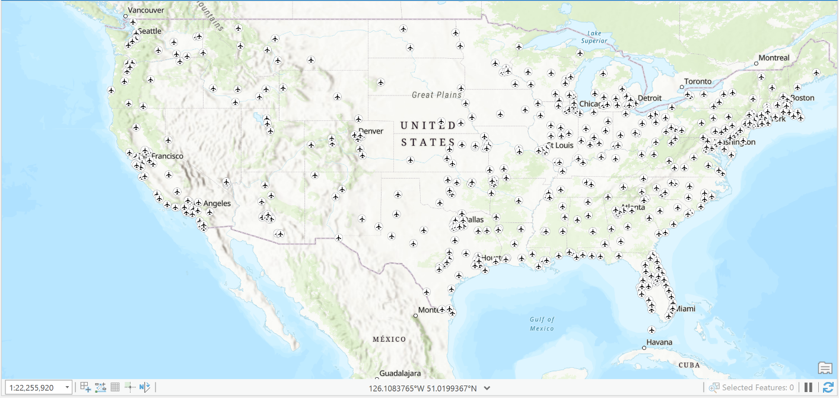

Figure 32 Airports with a point shapefile plotted as a layer in ArcGIS

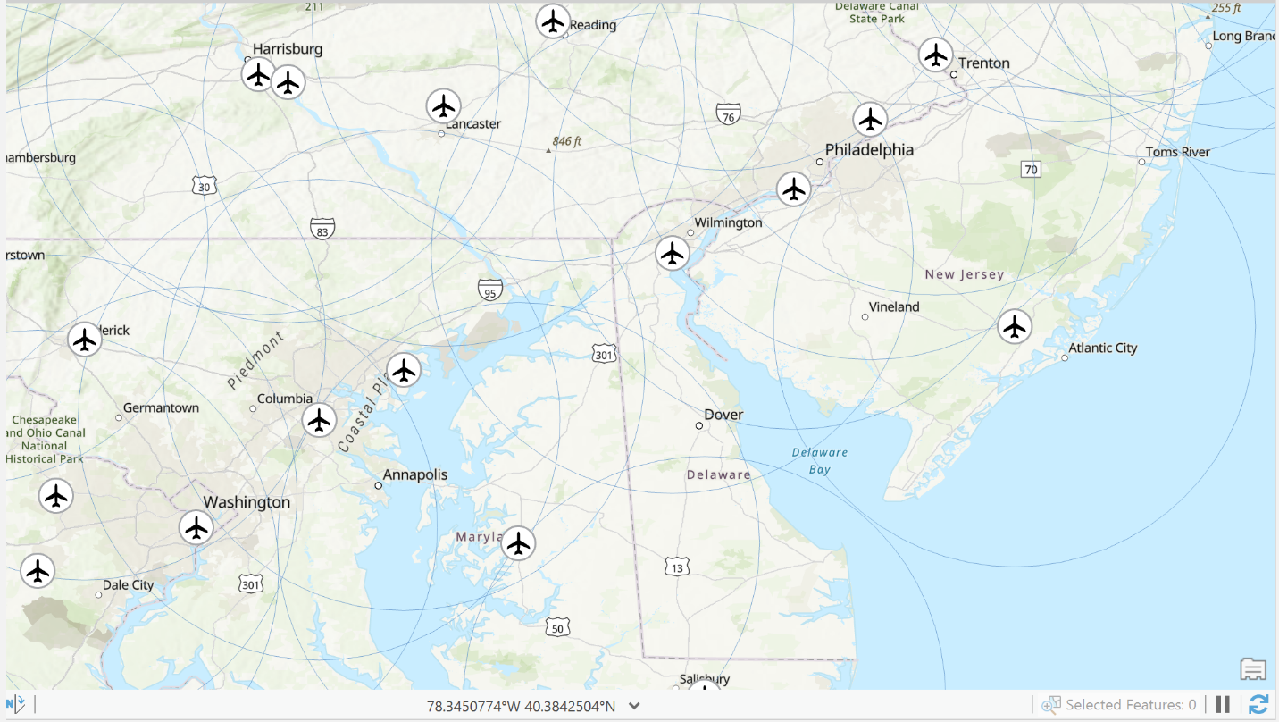

Figure 33 Airports plotted with a circle of approx. 50-mile radius from each airport.

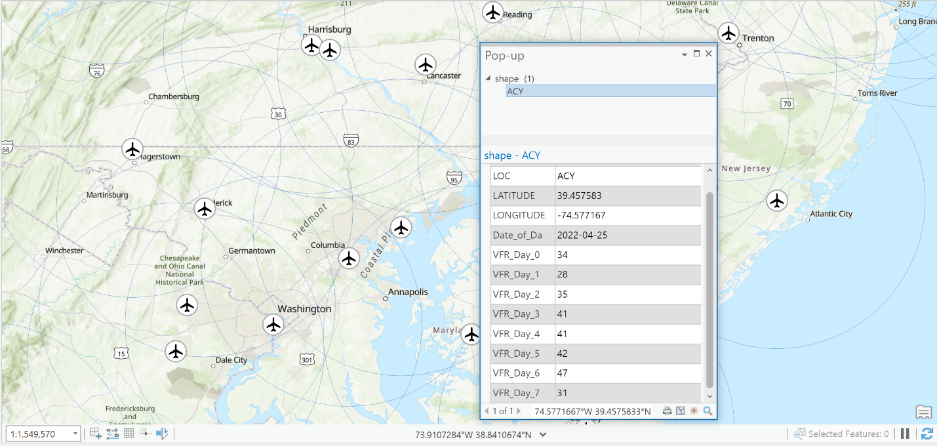

Figure 34 The Seven Day VFR Projections for Atlantic City Airport, NJ

## Tableau

The Tableau dashboard developed leverages data file exported from the Data Cleaner module and the supporting python files previously mentioned that encompasses the 500 airports, weather datasets and subsequent additional datasets implemented. Upon importing the combo_forecast.csv file, additional location data was included to provide the subsequent views that will be discussed. The additional excel file is called “FAA location data” which contains airport location data in regard to state, city, full name of airports and all composed in an if/else statement to be used in a Tableau column calculation to get the specific city, state and airport name of LOC’s. In total there are 7 views but only 5 of them pertain to VFR traffic analytics and subsequent values that were outputted from the python code. The pages are named as followed: Main Menu, Executive View, National Map, VFR Report, Histogram View, Exploratory Findings and Support.

### Main Menu

The Main Menu acts as a landing page when you first use the FAA dashboard. The purpose of the page is to provide the user full navigational power over the dashboard in one area. There are 6 buttons in the Navigational menu that will direct you to 6 pages, not including the Main Menu page, in the FAA dashboard:

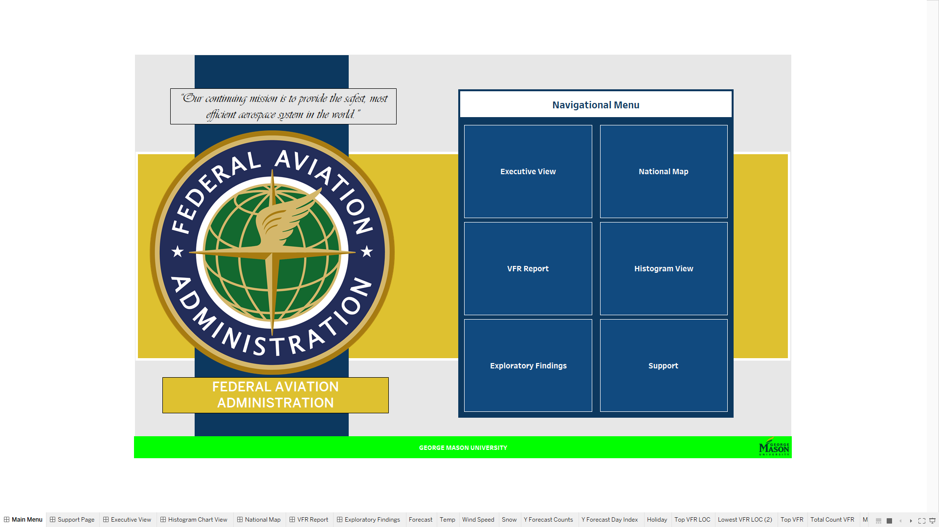

Figure 25 The Main Menu sheet in the FAA Tableau Dashboard

### Executive Summary View

Executive summary provides an overview of specific airports by dates and additional context in regard to weather, if the date specified is a holiday, model type used, model expression and several other metrics to provide a better understanding of VFR flights. The filters applied for selection for this view are the variables LOC, alias renamed to Airport, and Date, which is the date of the records being viewed. The following metrics were created upon selection of a specific airport and a date:

* KPI cards:
  + Airport Details provides information of the full name of the airport selected, the location of the airport that displays both the State and City. Upon hovering over the KPI, the tool tip will relay the abbreviated Airport name, the full name of the airport, the location and the region the airport is located at. The State and City information was acquired to supplement the LOC, latitude and longitude variables.
  + Holiday indicator indicates whether the date selected from the filter options is a holiday. The tooltip will display the answer along with the selected date.
  + Forecast provides information on the weather that will be displayed based on the selected date and airport, the precipitation probability and precipitation square root coefficient value.
  + Max temperature provides information on max temperature and the associated coefficient. The tooltip relays the same information along with providing the minimum temperature.
  + Wind Speed provides details on the wind speed measured by miles per hour and the associated coefficient.
  + Snow provides details on the snow amount and the associated coefficient.
  + Model type provides information on the model type used for the selected airport.
  + Model expression provides information on the predictive model’s expression.
* Charts
  + Average Pseudo R-Squared and Total VFR By Region bar chart provides information on total VFR values by region and the average pseudo R-Squared values.
  + Current VFR Forecast bar chart, provides information on the VFR value, the average VFR values and whether the current VFR value is greater than or less than the average.
  + Seven-Day Predicted Forecast line graph shows the VFR value over a seven-day period that can be adjusted by the Day index to display certain data range.
  + Intercept Histogram provides information on the intercept values and their frequency in regard to airport selected.
  + Pseudo R-Squared by Airport bar chart provides information on all the airports and their pseudo R-Squared and whether or not the R-Squared is strong or weak.
  + All Airports Pseudo R-Squared Histogram provides information regarding the frequency of Pseudo R-Squared values across all airports.
  + All Airports Intercept Coefficient Histogram provides information regarding the frequency of all the airports Intercept Coefficient values.
* Tables
  + Daily intercept and log, provides information on intercept, intercept coefficient, intercept coefficient squared error, log-likelihood, Ll-null and whether Log-likelihood is greater than Ll-null.
  + Sunrise and Sunset table, provides information on the sunrise time, sunset time, IFR value and the mean square error indicating whether it’s good, okay, or bad value.
  + Seven-Day Weather Forecast tables, shows the weather forecast over a seven-day period, max temperature, minimum temperature and precipitation probability. In addition, the table can be adjusted by Week number within a year to display previous weeks values.

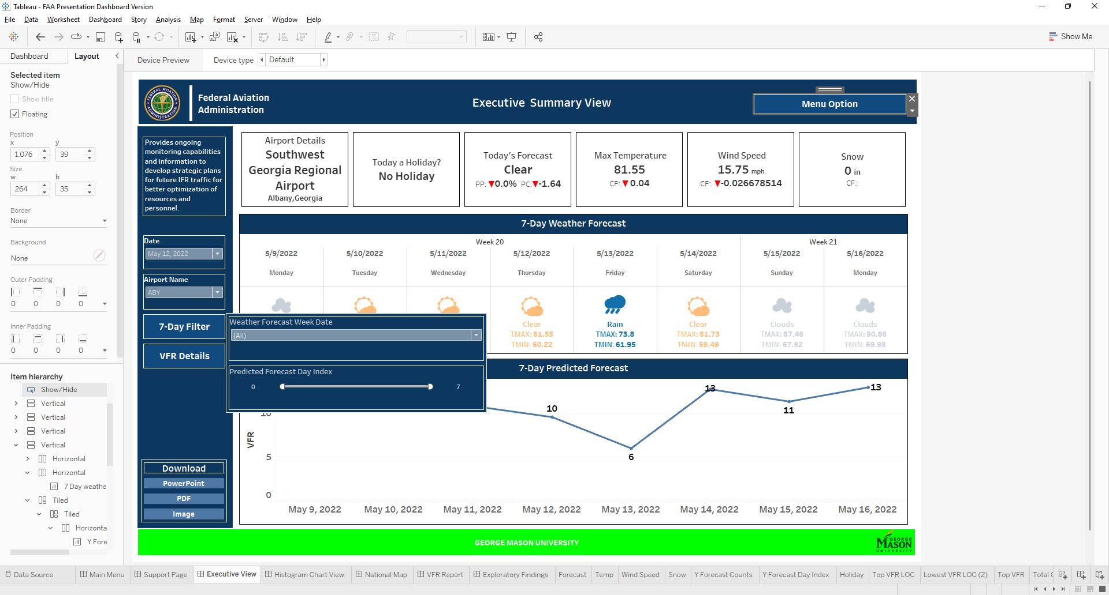

Figure 26 The Executive Summary view and the 7-Day Filter Show/Hide button.

In addition to metrics, additional buttons were created for navigational purposes, downloading pages and also hiding certain metrics. The following buttons were created to enhance the dashboard:

* Download
  + There are three buttons created to support the downloading of the current page being viewed and the subsequent pages into different formats, PowerPoint, PDF and Image. Downloading in PowerPoint will populate the Tableau page in PowerPoint, PDF in PDF format and Image as an image file.
* Show/Hide
  + The VFR Details button Shows/Hides Daily intercept and log table, sunrise and sunset table, Region by R-squared and VFR bar chart, Current pseudo R-squared bar chart, Model type KPI and Model expression KPI.
  + Seven – Day Filter button Shows/Hides the Seven Day Predicted Forecast charts Day index filter and the Seven Day Weather Forecast Week Number filter.
* Navigation
  + Menu Options button contains all the navigational buttons for the dashboard that will navigate from the current page you are viewing to the additional 6 pages. This button will be on each of the pages.

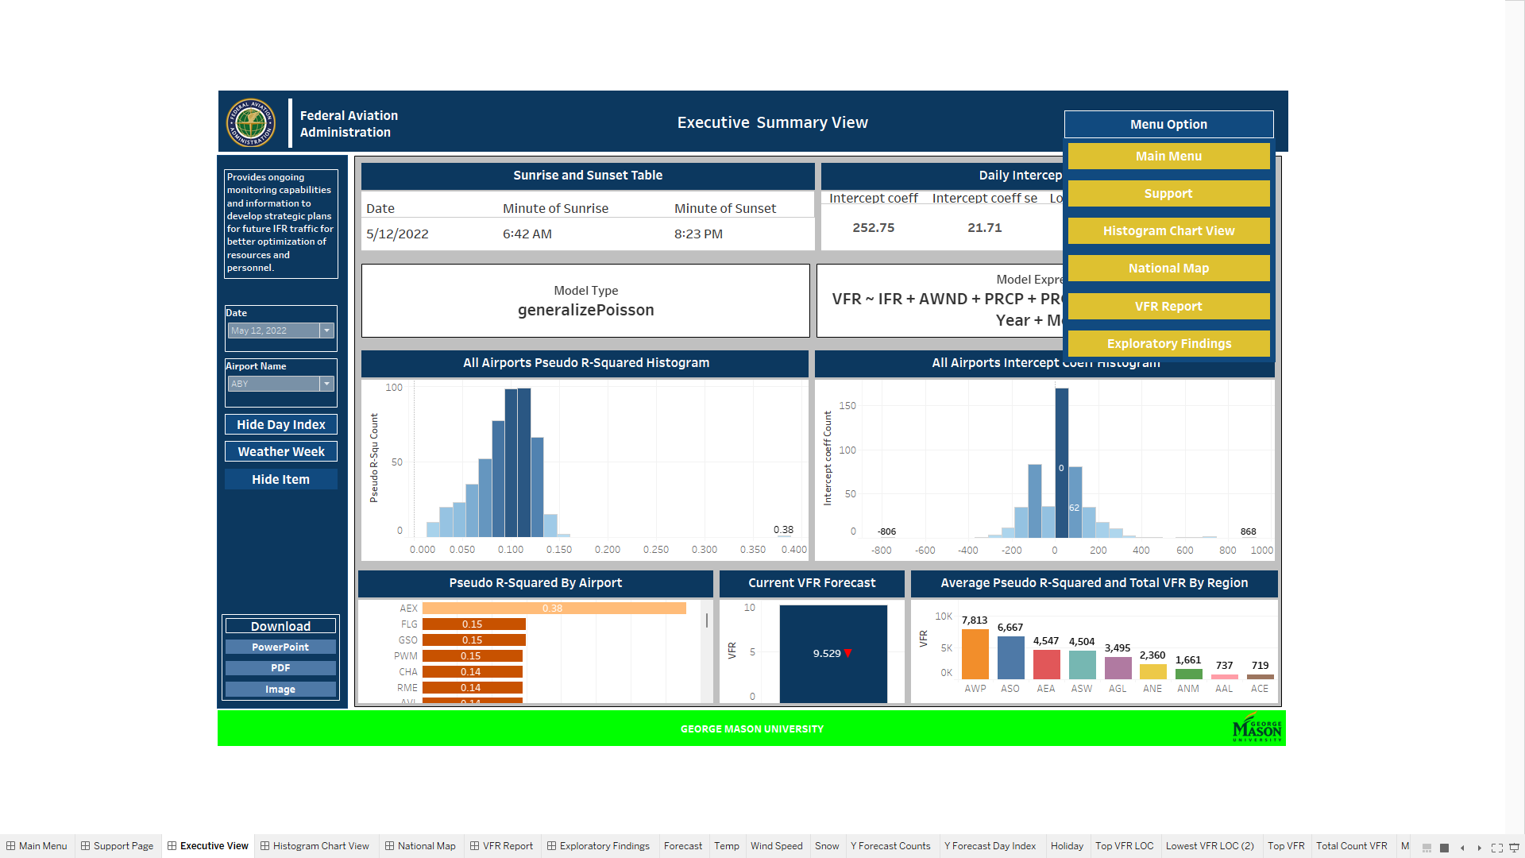

Figure 27 The Executive Summary VFR Details content and Menu Options buttons.

### National Map View

National map view provides a geographical location of the airports by their longitudes and latitude in addition to displaying how their VFR values compares to their neighboring airports. The map leverages size to compare VFR values and color to denote airports from one another. Also, the map is filtered down by Airport, State, Region and date. State is a Created Field calculation developed to leverages if – else statements when specific LOC is indicated. The following metrics were created:

* Map
  + National map uses longitudes and latitudes to create the map in addition to using LOC, VFR, created field leveraging Y Forecast variable, City, State, Airport Name, and Region in the tool tips. City is also created field calculation derived from LOC that leverages if- else statements when specific LOC is indicated. Map labels display Airports Abbreviation, the location in a City, State format, the VFR value and the pseudo R-Squared bar chart. Color indicates Airport abbreviation and size of the color dot indicates how large the VFR values is.

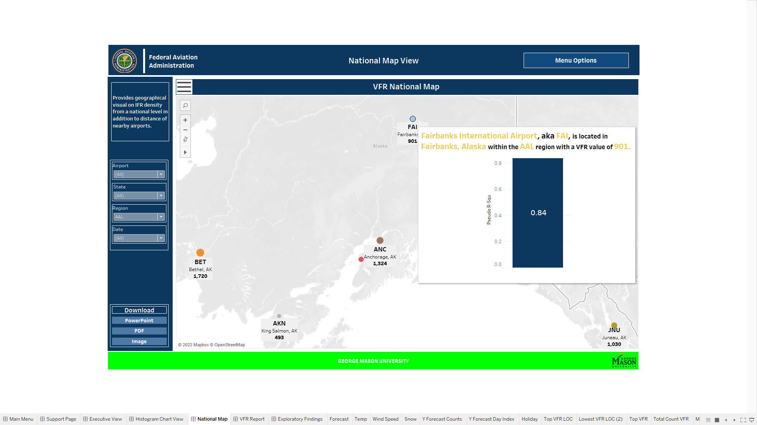

Figure 28 The National Map view and Pseudo R-Squared chart.

### VFR Report

The VFR Report view provides statistical analysis conducted on the predictive models and airport details in a report style format for downloading purposes. There are two tables that can be filtered by Airport name, Region and Date. The following metrics were created:

* Table
  + Total VFR By Airport is a table that provides details about the selected airport displaying the Region broken down by LOC, which is the Airport abbreviation, model type, model expression, Airport full name, Airport state and city, and total VFR value.
  + VFR Statistical Analysis Report is a table that provides details regarding the statistical analysis performed and specifically relays the Region broken down by LOC, Date, VFR value, Log-Likelihood, Ll-null, LLR p-value, Intercept, Intercept Coefficients, Intercept Coefficients SE and Pseudo R-Squared value.

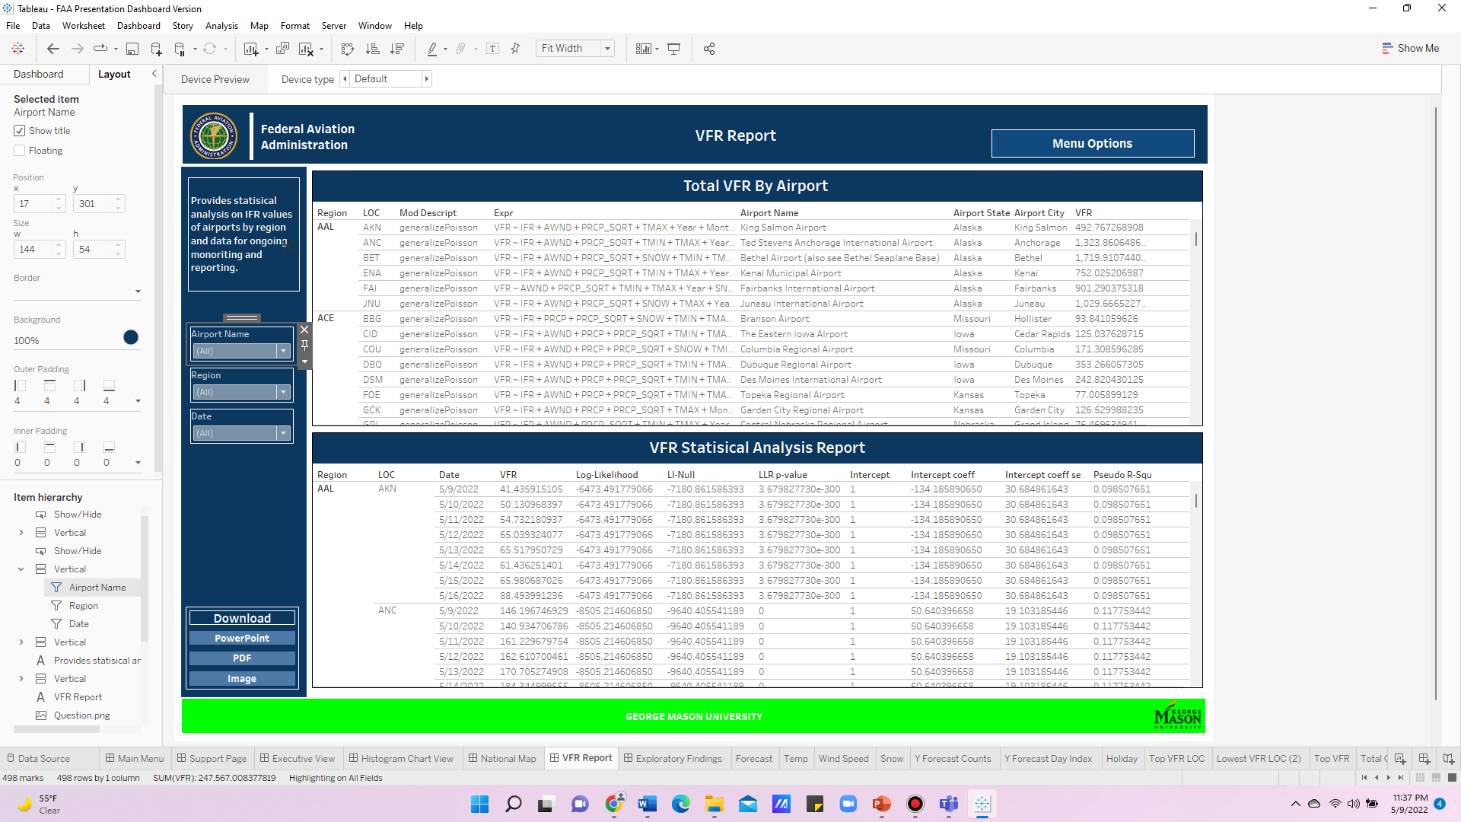

Figure 29 The VFR Report view and the Total VFR by Airport and VFR Statistical Analysis Report tables.

### Histogram Chart View

The Histogram Chart view provides an expansive view of the “All Airports Pseudo R-Squared” and the “All Airports Intercept Coefficient Histograms” fields found on the Executive view VFR Details button.

* Tables:
  + The histograms also have tables, Total Airport Pseudo R-Squared and Total Airports Intercept Coefficient Tables, that provide the same information regarding bins, distinct counts and color tables as seen in the histogram.
* Buttons
  + Both tables have Show/Hide buttons to expand each Histogram to full screen and also there is a legend button to provide information regarding the color hues.

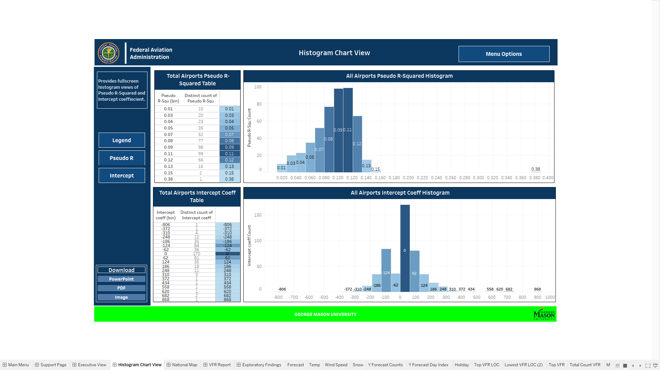

Figure 30 The Histogram Chart view, the Total Airport Pseudo R-Squared and Total Airport Intercept Coeff. tables.

### Exploratory Findings View

The Exploratory Findings page provides exploratory analysis in regard to VFR. The page provides information regarding highest VFR value, lowest, top and lowest cities, states, regions and additional charts and graphs regarding VFR. The page serves to provide users an understanding overall in regard to areas that are currently exceeding or underperforming and need additional support.

* KPI Cards:
  + Highest VFR Airport provides, as stated, the number one airport that holds the highest total VFR value. The KPI displays the airports abbreviated name and the total VFR value, and the tool tip displays the same with addition to the airports full name.
  + Lowest VFR Airport is similar to the Highest VFR Airport where the airport that holds the lowest total VFR value is displayed. VFR and Airport abbreviated names are displayed, and the airports full name is also displayed in the tooltip.
  + Total VFR provides the total sum of VFR in the data along with the average in the tooltip.
  + Total Distinct VFR Count provides, as stated, the total number of distinct VFR count and also the total VFR count.
  + Total VFR by Week displays the total VFR value by weekdays, in addition to providing the Maximum, Minimum and Total VFR values in the tooltip.
* Charts:
  + Total Forecast Count provides the total count of each of the weather forecast in the dataset.
  + Top 5 Regions by Total VFR provides, as stated, the top 5 regions that hold the largest VFR totals. The tooltip provides information regarding distinct count of states included in region and airport followed by VFR and Region name.
  + Bottom 5 Regions by Total VFR is similar to the Top 5 Region where the bottom 5 regions that holds the smallest VFR totals is displayed. The tooltip provides information same information regarding distinct count of states included in region and airport followed by VFR and Region name.
  + Top 10 States by Total VFR provides information, as stated, regarding the top 10 states with the highest VFR totals. Tooltips provide information regarding distinct count of airports.
  + Bottom 10 States by Total VFR provides information, as stated, regarding the bottom 10 states with the lowest VFR totals. Tooltips provide information regarding distinct count of airports as well.
  + Top 10 Airports by Total VFR displays the top 10 airports that yielded the highest VFR total.
  + Bottom 10 Airports by Total VFR displays the lowest VFR totals held by airports limited to display only 10.
  + Top 10 Cities by Total VFR displays the top 10 cities within the dataset that yields the highest VFR totals. The tooltips display state of the airport and the distinct count of airports in the city.
  + Bottom 10 Cities by Total VFR displays the bottom 10 cities within the dataset that yields the lowest VFR totals. The tooltips display state of the airport and the distinct count of airports in the city as well.
  + VFR By LOC displays all the airports by VFR total within the dataset along with the VFR average in the tool tip.
  + VFR Histogram displays the frequency of VFR values in the dataset.

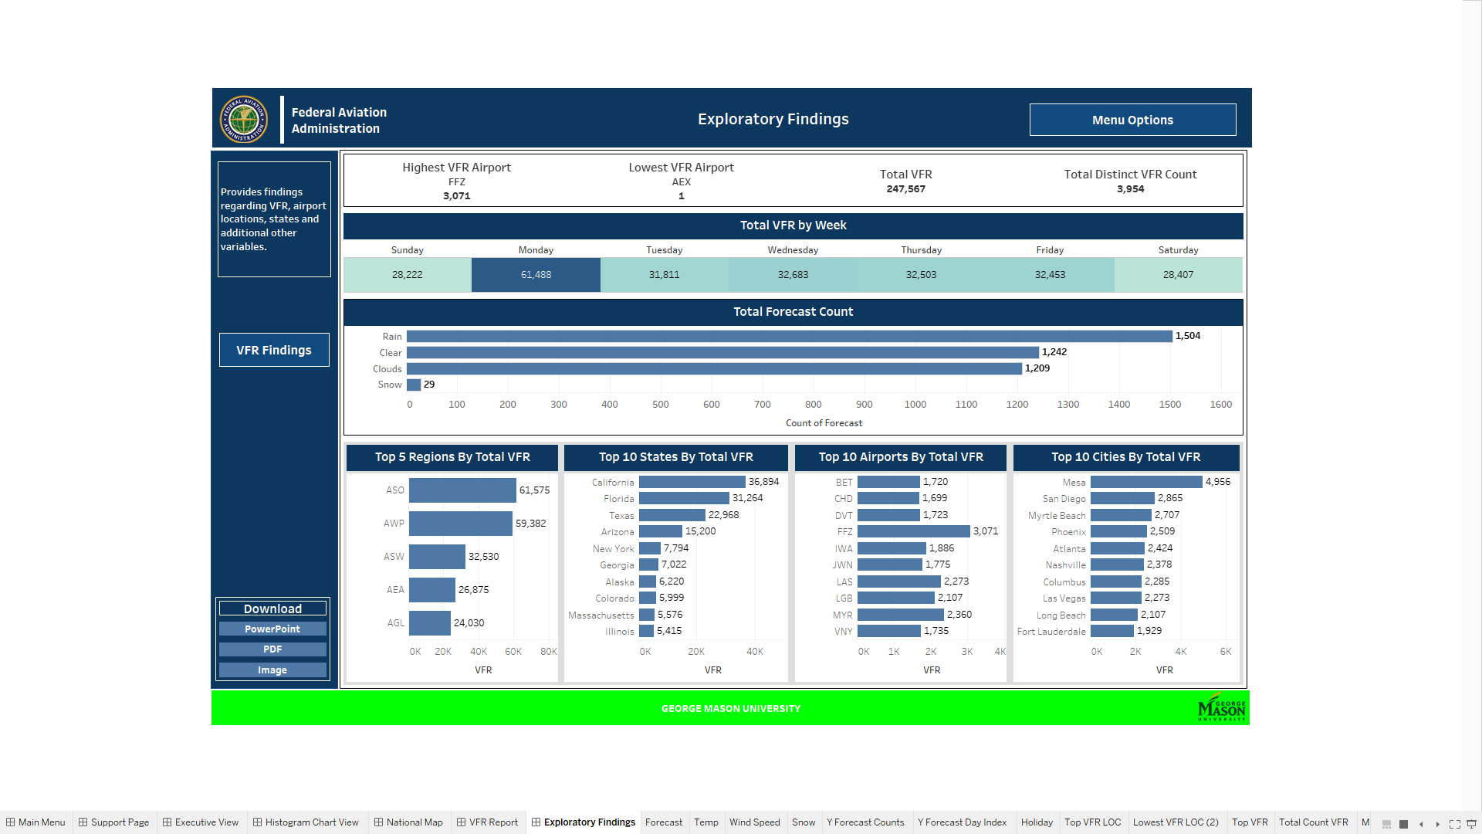

Figure 31 The Exploratory Findings view and its charts and KPI.

* Buttons
  + VFR Findings Shows/Hides the VFR By LOC, VFR Histogram, Bottom 5 Regions by Total VFR, Bottom 10 States by Total VFR, Bottom 10 Airports by Total VFR and Bottom 10 Cities by Total VFR charts.

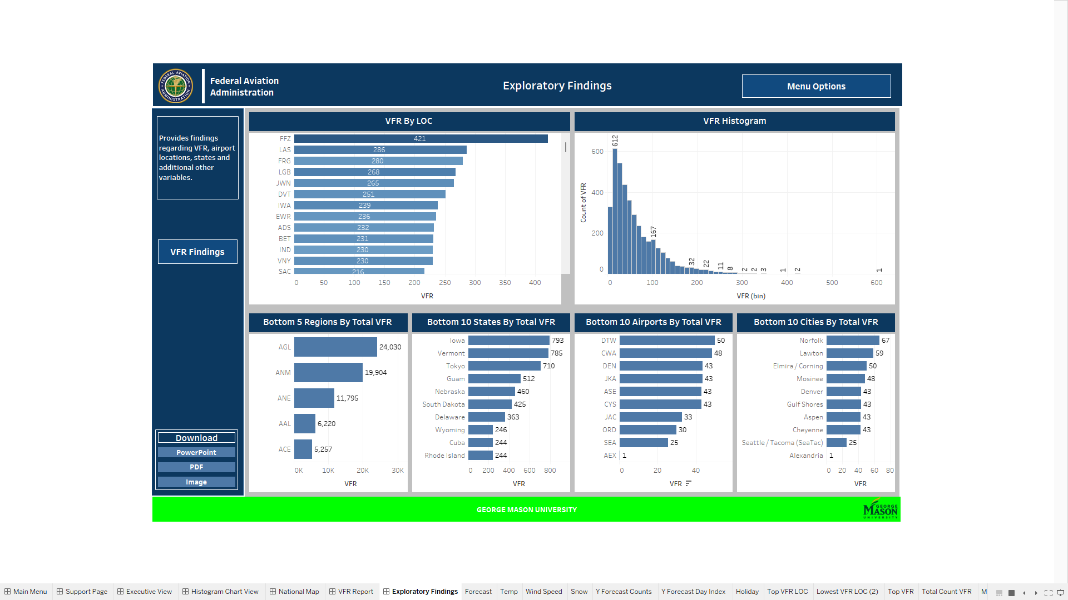

Figure 32 The Exploratory Findings VFR Findings button and its charts.

### Support View

The Support View page provides information about who to contact for a specific problem. In addition to documentation being provided, members on the Flightify teams contact information is also provided. Support is divided into two sections: Data Support and Tableau Technical Support. Data Support refers to specifically the python model, code, and all the python files used to develop the Tableau csv output. Tableau Technical Support refers to the Tableau Dashboard, charts, graphs, KPIS, data source problems, errors in filtering and additional problems that are faced when using the Dashboard.

Additional Tableau documentation will be provided in conjunction to this report.



Figure 33 The Support view and POC contact information.

# Findings

In the process of working towards finding a model that could best predict the VFR traffic accurately, the team worked with the following models

1. Multiple Linear Regression (MLR)
   1. Out of predictive range producing negative VFR flight volume, high error
   2. This method was not utilized for any airport
2. Generalized Linear Models (GLM) Negative Binomial
   1. Used for one airport, Alexandria International Airport (AEX). The airport, Alex. Intl. Airport (AEX) uses the Negative Binomial Regression Model which is similar to the Generalized Poisson Distribution but allows for a difference in mean and variance.
3. Consul’s Generalized Poisson Regression Model (GP-1)
   1. In predictive range, reduced error, fits variability in VFR from unknown variables using a dispersion parameter in the probability distribution, mean, and variance formulas. This allows for a difference in the mean and variance.
   2. This method chosen for 497 airports
4. Two airports did not converge, IFP and SBD. Their forecast results are not included in the Dashboard.

Of these models, the Generalized Poisson Distribution has been found to be the best predictor of the VFR traffic, as we are dealing with count data.

The Generalized Poisson Regression Model allows for over-dispersion and under-dispersion in the datasets, capturing the variability in VFR volume from unknown variables by introducing the dispersion parameter, alpha. The models display the goodness of fit evaluator, Pseudo R Squared, up to .149665 for the selected airports. A few of the airports along with their Test Root MSE and Pseudo R Squared are shown in Table 13. Alex. Intl. Airport, AEX has a Pseudo R Squared of .380025 but is forecasting 0 VFR.

Table 13 Airports of Interest, Model, Test Root MSE, Pseudo R Squared

|  |  |  |  |  |
| --- | --- | --- | --- | --- |
| Region | Airport | Model | Test Root MSE | Pseudo R Squared |
| AEA | ACY | GP-1 | 16.91 | .108992376 |
| AEA | LGA | GP-1 | 72.14 | 0.091672999 |
| AEA | EWR | GP-1 | 80.61 | 0.102344985 |
| AEA | TEB | GP-1 | 24.51 | 0.095891792 |
| AEA | JFK | GP-1 | 27.3 | 0.090908973 |
| ASO | CVG | GP-1 | 5.03 | 0.073364957 |
| AWP | PRC | GP-1 | 63.44 | 0.114389752 |
| AWP | DVT | GP-1 | 69.51 | 0.074708496 |
| AWP | VNY | GP-1 | 61.02 | 0.084518067 |
| AGL | GFK | GP-1 | 119.65 | 0.138741636 |

For Atlantic City Airport (ACY), NJ, the predicted VFR vs the actual VFR from January 2017 to December 2021 is shown below using the randomly selected test set. The test set contains the actual VFR counts measured from the airport, and acts as an unseen dataset which would gauge the accuracy of the model. As can be seen from Fig.21, the actual VFR Counts (shown in red) closely mirrors the VFR counts predicted by the model (shown in green), except for an outlier in the actual VFR count data.

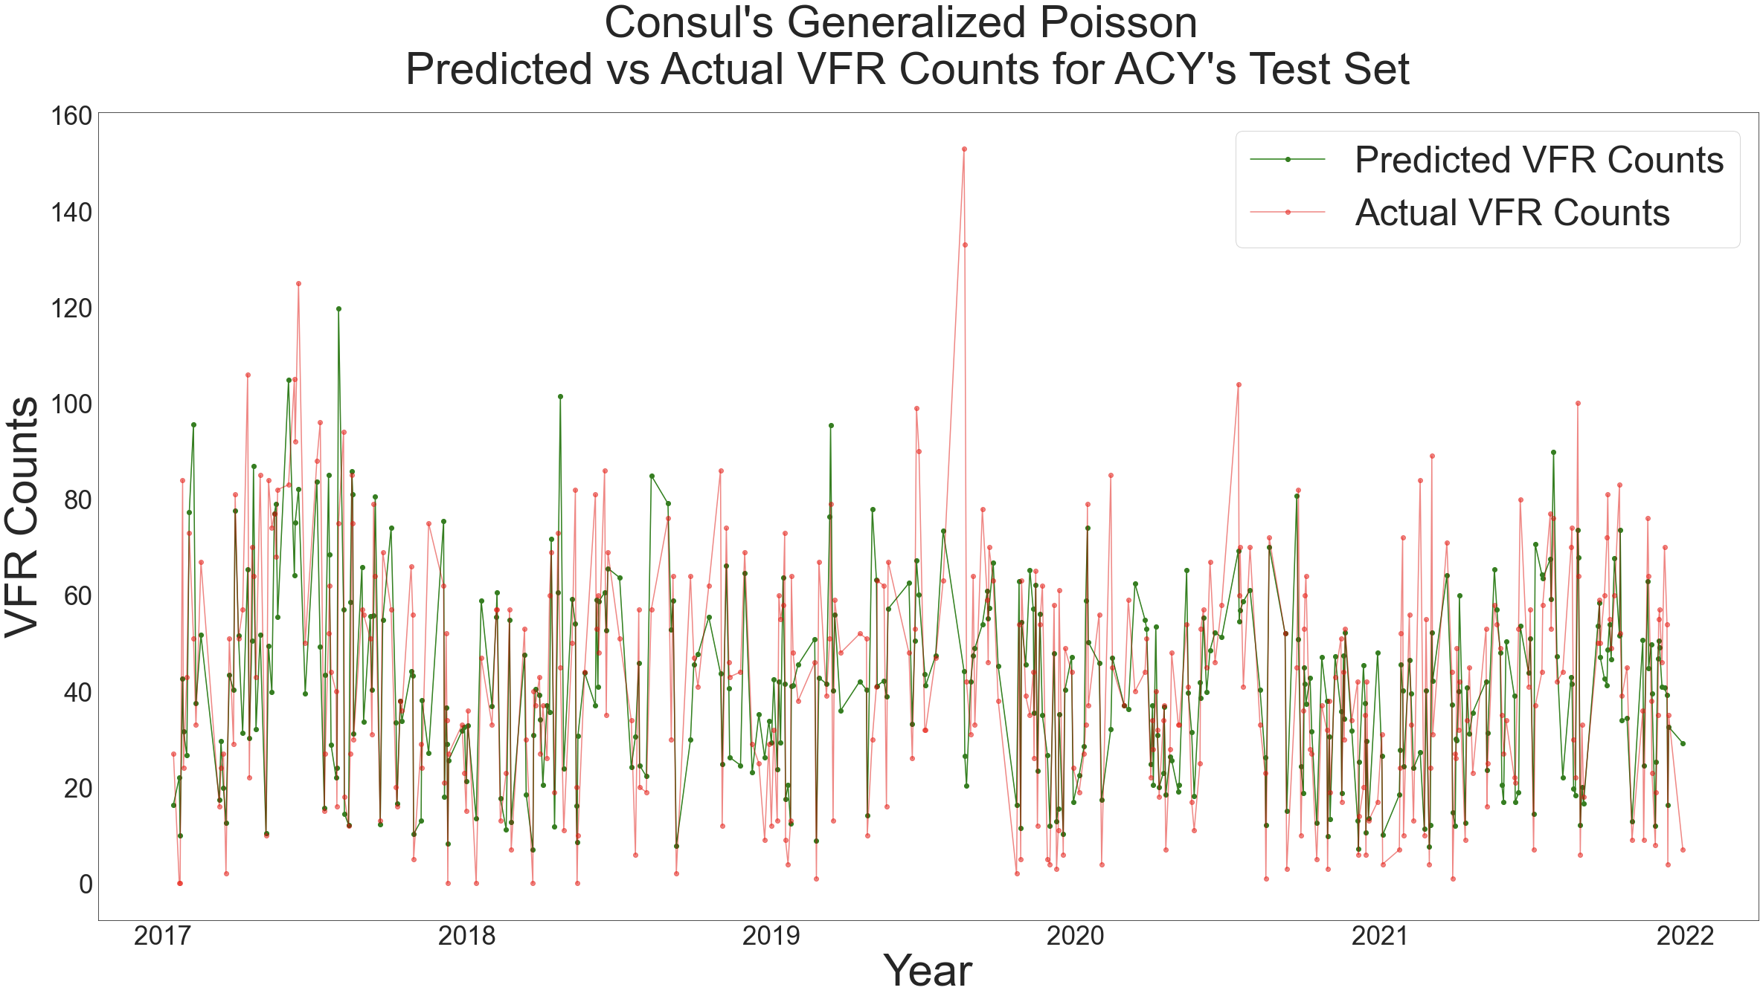

Figure 35 Consul's Generalized Poisson Regression for ACY: Predicted vs Actual Counts using Test Set

Weather was a significant variable in the modeling process. Since VFR almost exclusively uses visual flight rules, which consequently requires good weather – high visibility, low precipitation, low wind etc. to fly, weather is a strong determinant in deciding whether a VFR flight will be airborne or not.

Since the VFR flights are often flown by private citizens for their own benefit, whether a particular day was a holiday or not was also a factor in the prediction of the VFR flights. It was found that the days preceding big holidays like Thanksgiving, Christmas and New Year’s had more VFR traffic than the holidays itself for certain airports.

Month, Day, Year, and Day of Week were included as predictors. This captured spikes for certain days and also possible patterns for covid years. IFR flight volume was found to be a significant predictor.

# Challenges

The team faced challenges in terms of first deciding which data to use for the prediction process, and then making learned assumptions regarding the significance of variables which determine the VFR traffic. The process of finalizing the dataset and assumptions is given below.

## Data Selection

### VFR/IFR Data

The initial dataset that was planned to be used was that of CountOps data, which was used by the previous team, Flightify. It was a comprehensive report for each airport which had the VFR data for each hour of the day along with the IFR data. After trying to use the report, the following issues were met with.

1. The detailed CountOps data is not available at the FAA website, it would have to be downloaded by the FAA internal staff and shared with the team for each individual airport.
2. Since the data included hourly count data for VFR, the size of the data for five years from 2017-2022 for a single airport was huge. Since initially the plan was to model for 500 airports, the total expected size of the data was very large and would need big data processing software.
3. Since we planned to use weather data along with the historical data, hourly weather data would also have to be found and included with the already huge dataset.

Hence, the team decided to go with the TowerOps dataset in the FAA website, which is available for the public. It has data on daily IFR and VFR traffic for years 2017-2022. The team downloaded the data from the website and added in the additional variables of weather, date components and day of the week to complete the dataset used for prediction of VFR flights.

### Weather data

Finding historical weather data that was accurate and consistent was a challenge for so many airports. Sources needed to have data available for many years. We needed to find a publicly available, no cost source. Some sources were easier to access than others. Data for precipitation, snow amount, temperature, and wind speed were necessary for all airport locations across the country dating back to 2017. We found the most reliable and accessible historical source to be from NOAA.

Historical information was not the end of the team’s data search. To forecast the VFR flights, we need future data for all the same predictors we used in building the model. This meant we needed to find a source that was consistent for all airports and available for at least seven days into the future. We also needed to be able to convert the data into the units of the historical information we had with NOAA. This took a solid two weeks of trial and error of investigating several sources. The access method was also of vital importance, since manually pulling weather information from a website for 500 airports would make the model essentially unusable. The team quickly realized that this information needed to be pulled automatically within the python system sparing the user the burden of a laborious task, otherwise the entire system would not be utilized.

This challenge is accomplished by pulling forecast information from the Open Weather API within the python Forecast Module. It produces a JSON response where the predictors are then extracted and placed into a Pandas Data Frame for use in the learned model. VFR traffic is then be predicted for the current plus the next seven days. A combined csv for all airports is created for the use of the Tableau Dashboard and a combined csv to be used in the creation of the shape file is finally exported and saved on disk. The Open Weather API had the necessary predictors, for the necessary time period, complete for all airports, and free with the use of an API key.

### Holidays and Date Components as predictors

We found that dates surrounding holidays and weekends for some airports had an increase in VFR traffic; thus, these surrounding days should be considered the critical days to assess and model. Yet for some it had no increase. Holiday as a binary variable caused computational problems with the Generalized Poisson Regression Model, but using Year, Month, Day, Day of Week as predictors served as a successful replacement to a single binary variable. If the date components are significant for a particular airport, then they are included as predictors.

## Modeling

After studying the nature of VFR flight behavior, the main assumption is that weather is an important variable in predicting future VFR flights. The team conducted research by talking to members of the aviation community who fly and work with airplanes that fly using VFR. They helped us understand the decision process a pilot uses to fly or not fly and discover the main factors that keep them on the ground and the factors that motivates them to fly. Weather can do both, it halts or encourages the decision. We don’t know the personal aspects in the lives of each pilot in every airport across the country making the decision to fly but we do have access to a main motivator, weather.

A special thank you to Joel Jenkinson, Airport Director of the Addison (ADS) Dallas airport and members of Commemorative Airforce (CAF) for their assistance in helping the team understand behavior aspects of VFR traffic and terminology. In the beginning of the project the team was learning the language of aviation and the terminology of FAA. One of the team members got the idea to contact an airport that supported VFR traffic and ask questions about some confusing terminology and definitions. For example, does a VFR airport also support IFR flights, and the definition of local flights. Mr. Jenkinson at ADS was more than happy to answer questions and clarify definitions. He also described the major effect weather had on VFR flights. One of the team members also know members of the CAF which acquires, restores, and preserves in flying condition historic combat aircraft. The CAF fly using VFR. During a virtual meeting where several pilots, and maintenance crew were assembled, the team member was able to attain answers to questions about proximity of flight school locations to airports. The team appreciates the willingness of the Commemorative Airforce and Joel Jenkinson to help the team have a better understanding of VFR flight behavior and terminology.

### MLR issues

MLR predicts VFR traffic in the range of negative infinity to positive infinity. Large negative predictions were substantially increasing the error, since all actual VFR counts are in the positive range. MLR was not a good choice for modeling counts of things. An early residual plot for airport Fairbanks International Airport shows that the residuals are not random about the x axis, thus suggesting that a linear fit is not appropriate.

Figure 36 Residual Plot vs sqrt PRCP for FAI

# Summary

The result of the project is the successful implementation of the Generalized Poisson Regression Model to predict the VFR traffic at 500 airports and producing the shapefiles to be used by FAA in their Geographical Low Altitude Risk Exposure (GLARE) ArcGIS platform and the in-depth interactive Tableau Dashboard. Each is detailed below.

## Consul’s Generalized Poisson Regression Model Success

Section 3.3 discusses how the team found success in modeling the behavior of VFR traffic. The key to success is based on modeling VFR flight behavior using the Generalized Poisson probability distribution seen in Figure 22 Probability distribution and variance and mean functions of the GP-1 model (Sachin Date copyright under CC-BY-NC-SA) [28]. Not only does this model keep the predictions in the positive realm, but it handles the real-world data situation of variability in VFR. The traditional Poisson distribution requires the mean to equal the variance. This is often not the case for most datasets. Over-dispersion, when the variance is greater than the mean, or under-dispersion, when the variance is less than the mean occurs. The introduction of the dispersion parameter, alpha, into the probability distribution, mean, and variance formulas solves the problem of handling these situations. Our standard errors of the coefficients greatly improved using this model and predictions track well overall with the test set data.

## Trends Discovered

The average of the evaluation parameter, pseudo R squared, for FAA’s nine regions shows that the model explains variability in VFR traffic better in some areas of the country than it does in others. The model fit the training data in New England the best at .12 and Western Pacific near .075. The grouping of four regions, Great Lakes, Eastern, Northwest Mountain, and Central were second highest, and the grouping of Alaska, Southern, and Southwest were third highest.

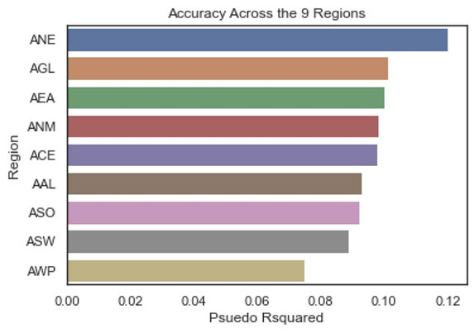

Figure 37 Average Pseudo R Squared for 9 FAA Regions

## Tableau Capabilities

The Tableau dashboard provides ongoing monitoring and reporting capabilities regarding VFR values over a range of dates, airports, regions, states, and many other filter options to drill down the data. The dashboards provides daily and weekly insight in addition to providing insight about leveraging multiple variables or only single selection options. Reports can be downloaded, user ownership can be shared, the dashboard can be presented for larger groups or from small internal groups. The Tableau dashboard also has the potential to expand beyond the current views to provide more detailed or more broad views of the FAA data. Downloading the report sheet and ingesting new data complied will potentially also face future issues regarding data retention.

# Future Work

There are several areas where improvements can be made as this project was a process in understanding what is possible, what is beyond our means and what is not feasible. Improvements on current processes and for future work has been broken down into these four key stages below:

* Preprocessing
* Modeling
* ArcGIS
* Tableau.

Each of these stages holds many processes that have provided the current output for this project and as such, has room for enhancements in its efficiency and delivery. Each of these stages has room for growth and for new development with additional investments and technical solutions to be addressed.

## Preprocessing

As the sponsor, FAA, plans to include more airports into the VFR Prediction system or to make longer term predictions for VFR traffic, the data preprocessing might need updates to make it run faster or smoother, as given below.

* **Predicting VFR flights far into the future for a given airport is of interest for long term planning.** For example, predicting VFR flight amounts out to 2045 for a certain airport may be done if we began with the base information derived from this project. Using averages would serve as a base on which to build. All of this may be useful if applied to new information such as socio-economic factors and other variables of interest that change over time to forecast the future VFR flights. Adding a Geospatial layer for dates far into the future can be achieved with the current project serving as a base for new projection methods with a different scope and perspective.
* **Improve running time of Data Cleaner module.** For new data ingestion, the current running time is 20 minutes. ​Improving the running time will be necessary as larger ingestions will take place and having a long run time will make creating models, and VFR outputs difficult to meet deadlines and goals.
* **Increase data scalability.** Increasing the capacity for data ingestion will require expansion from the current ingestion of 1000+ datasets. Enhancing the current pipeline and modules will be needed to maintain larger ingestions.
* **Integrate Open weather data**. Access and investing in the historical data from Open weather will improve the accuracy of the model. Currently, the project has been using the free trial plan for accessing the Open Weather data and for future expansions in scalability and data ingestions, investing in a higher tier access to the Open Weather data will be needed to gain access to more historical data.
* **Create API for public to query from database.** External personnel can query database for output into usable format, such as csv.​

## Model

Making a model perform better is always a challenge which when realized, yields many rewards. The team was bound by time and money in researching the variables which would accurately predict the VFR traffic.

* + **Find more predictors.** Improve accuracy of model by exploring more VFR predictors currently existing or newly ingested. As previously stated, our model's current pseudo R- squared value is .149 and we would like it to be within the .2-.4 region. To accomplish this, exploring new variables or reinvestigating old ones disregarded will be necessary to improve the accuracy of our model.

## ArcGIS

The current ArcGIS layer is static, where the user has to run the code every seven days, which is the number of days the VFR traffic is predicted for, and then layer it in ArcGIS.

* + **Create real time update.**Explore if automated update capability is impossible for data ingestion and refreshing. ​
  + **Change from Static to Dynamic Layer.** Dynamic layer requires new file for ingestion of data as static does not have capability for ingestion of new data. Finding a method to automate newly ingested data without having to upload a new file each time will need to be explored to reduce the time spent with uploading and downloading files for ingestions.​

## Tableau

The suggestions to improve the Tableau Dashboard are detailed below.

* + **Create Flow using Tableau Prep.**Preprocessing Flows will perform iterative processes for larger data ingestion and cleaning for specific variables. After the csv is outputted from the python module, there are several areas where preprocessing has to take place specifically in regard to changing data types, creating calculations for KPI indicators, removing irrelevant values, replacing NA’s with an appropriate abbreviation and so forth.​
  + **Develop Real Time Airline Traffic Map.** National map displaying real time traffic airlines that are currently being coordinated and managed will help indicate current number of flights in route, arriving and departing. It can also serve as simulation running historical data and observing traffic and the methods applied to manage them from daily, weekly and monthly basis. ​
  + **Develop distance KPI.**Metrics pertaining to route distance will optimize fuel consumption and resource distribution. Understanding the distance between airports and between flights can support if emergency landings need to be taken and where the closest refuel station is.​

​

​

# Appendix A: Code References

## GitHub

Flightify 2.0 GitHub link: <https://github.com/mazen93m/Flightify-2.0>

## Expanding Team Flightify: Predictable VFR Air Traffic Forecasting in All Major Airports in the US

Aircraft using VFR usually are not required to file a flight plan and are not automatically monitored by air traffic control. More resources are required to manage their flights which can cause a safety risk when airports are caught unprepared by a large influx of VFR traffic. Therefore, Team Flightify 2.0 models and forecasts future VFR flight volume in class G airspace, which will enable the FAA to assess risk and allocate proper resources. The partner will be able to integrate the predictions into the ArcGIS (GLARE) platform.

## Data Location

To access Team Flightify 2.0’s datasets, please navigate to the following GitHub site where they are located: <https://github.com/mazen93m/Flightify-2.0>

## Installation

### Instructions for acquiring openweathermap free API key code:

An API code is required to run the Forecast Module. Below are instructions with screen shots to attain the API code from Open Weather [31].

* Go to website: <https://openweathermap.org/api>

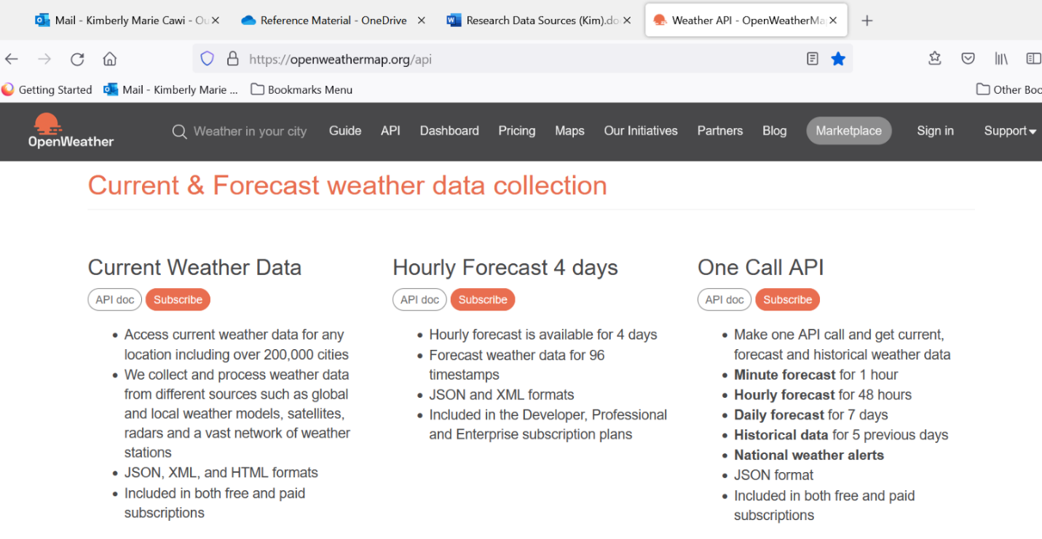

Figure 38 Screenshot from Open Weather. Subscribe to One Call API

* Click Subscribe under One Call API

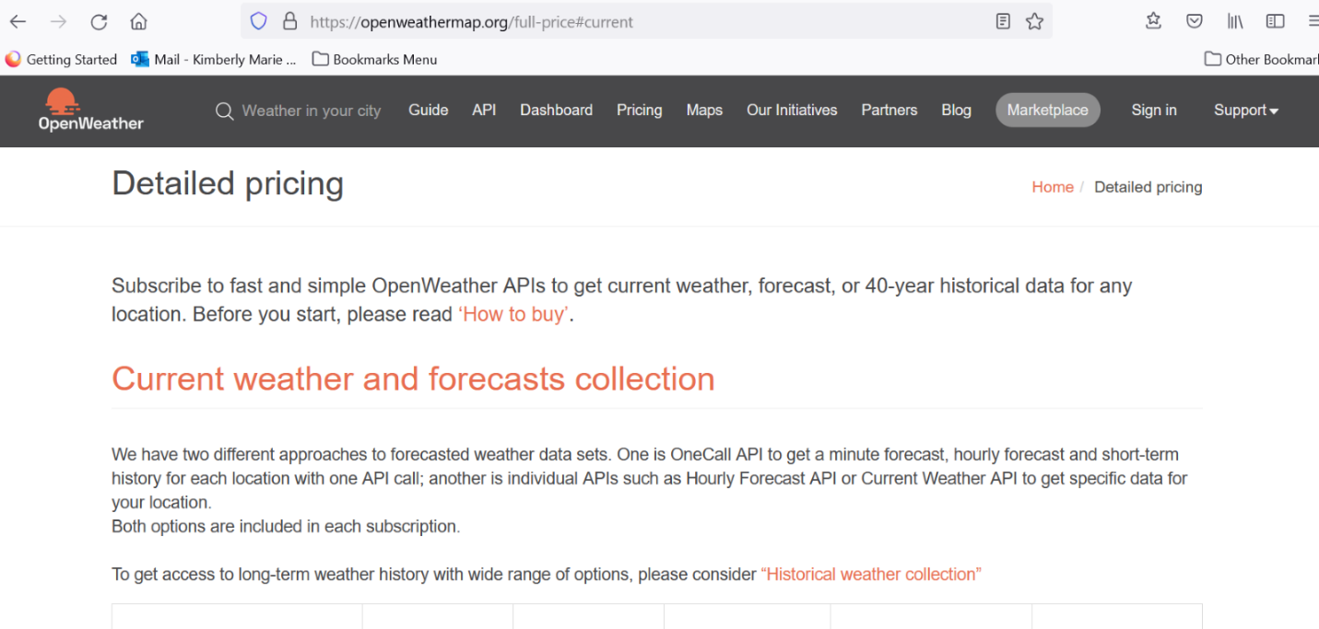

Figure 39 Screenshot from Open Weather after clicking Subscribe for One Call API

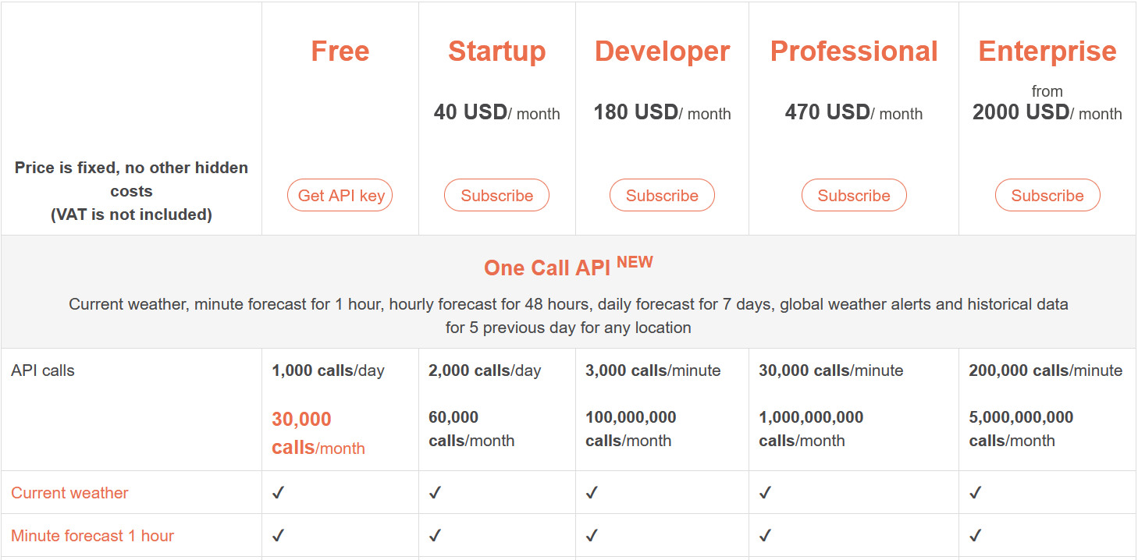

Figure 40 Screenshot from Open Weather. Scroll down to see Pricing Options.

* Choose "Get API Key" Under Free column for 1000 calls/day and 30,000 calls/month

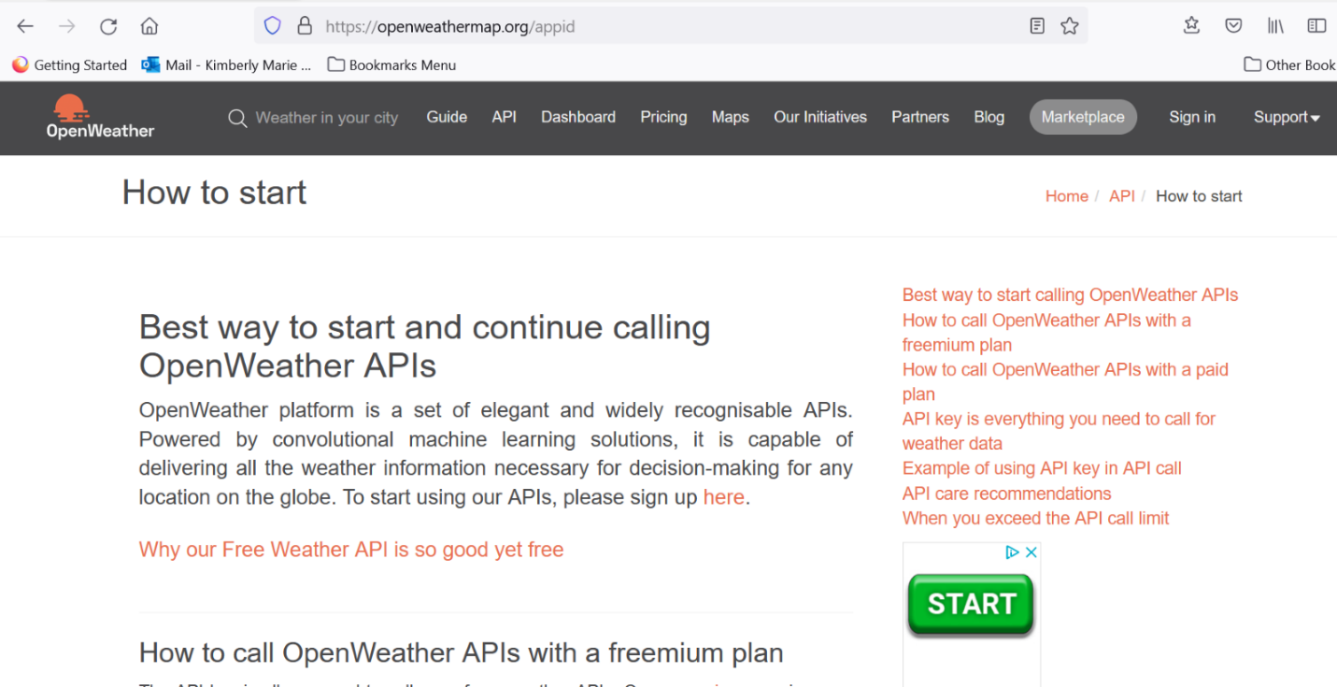

Figure 41 Screen shot from Open Weather. Begin sign up.

* Click sign up here.
* Fill out form.
* Click Save.

### Data Cleaner

Run the Dataset Cleaning Tool when historical data is updated.

Required files in current directory:

* airports.py
* dataCleaner.py
* NOAA.zip files extracted
* Tower_ops_airports.zip files extractedfaa_lat_long.csv
* updated_holidays.csv (unused, but available)

### Model Module

Run the Model Module when historical data is updated. Otherwise, it is not necessary.

Required files in current directory:

* glm_modeling_scale.py
* datasets.pkl

### Forecast Module

Required files in current directory:

* Pull_Forecast_api_openweather.py
* model_dict.pkl
* near_weekend_holiday_dates.csv

For Pull_Forecast_api_openweather.py, make sure API code is input on line #102

Important: Insert your API key in place of {API key}, drop braces, no spaces

openweather_api = 'https://api.openweathermap.org/data/2.5/onecall?exclude=hourly,alerts,minutely&appid={api key}&units=imperial'

### Tableau Dashboard

Required files in current directory:

* FAA Dashboard
* combo_forecast.csv
* FAA Location Data excel (to collect location data for airports and automate the else/if statement code for Tableau Column calculation.)

### Shape File Module

Required files in current directory:

* Shape File Module Code.py
* shape.csv

## Usage

Before using the system insert your open weather API code in the Pull_Forecast_api_openweather.py script in line 102. Instructions in Forecast Module above.

-If historic data is updated, then begin with the Data Cleaning Tool and follow the installation order.  
-If no change in historic data, begin with the Forecast Module, then proceed to Tableau Dashboard, then the Shape File Module.

## Credits

George Mason Data Analytics Engineering Program

DAEN 690 Spring 2022 Team Flightify 2.0: Dr. Charles Howard, Sabitha Pongadan, Alec Gray, Nida Sharief, Mazen Mohamed, Kimberly Cawi, Vasanthi Pulusu, Bharat Kumar Challakonda

Summer 2021 Team Flightify: Deanna Snellings, Walter Benitez, Brittany Burwell, Jason Chern

# Appendix B: Risk Section

## Sprint 1 Risks

| **Risk Name** | **Description** | **Probability** | **Impact** | **Mitigation** |
| --- | --- | --- | --- | --- |
| Missing Data | Dataset might be incomplete | High | High | Explore whether imputing missing data or deleting rows would be beneficial to the project |
| Wrong Data | Selecting data which does not meet the requirement of the project | Medium | High | In the partner meetings, give priority to map out the exact problem statement and decide on the dataset that addresses the problem. |

## Sprint 2 Risks

| **Risk Name** | **Description** | **Probability** | **Impact** | **Mitigation** |
| --- | --- | --- | --- | --- |
| Incomplete Data | The fields in the dataset might not be complete | Medium | High | Research and implement ways to impute missing data without losing the integrity of the dataset. |
| Insufficient Data | The current dataset received might not contain all the pertinent information to accurately predict VFR Traffic. | Medium | High | Perform preliminary statistics on the dataset to find out whether the current variables sufficiently explain the traffic variation |

## Sprint 3 Risks

| **Risk Name** | **Description** | **Probability** | **Impact** | **Mitigation** |
| --- | --- | --- | --- | --- |
| Poor Data Quality | The quality of the data used for analysis is not optimal | Low | High | Since the data for the project comes from FAA and NOAA, the quality of data is considered good. |
| Data Security | The data used for analysis is secured and cannot be shared in public platforms | Medium | Low | The data used for the project is sourced from publicly available datasets in the FAA website. |
| Prediction Accuracy low | Despite running various models, the prediction accuracy might be low. | Medium | High | Make sure that all possible variables that affect the dependent variable are considered in the model |

## Sprint 4 Risks

| **Risk Name** | **Description** | **Probability** | **Impact** | **Mitigation** |
| --- | --- | --- | --- | --- |
| Biased Interpretation of models | The results of modeling can be interpreted to fit the knowledge of current VFR flight traffic | Minimal | High | The current predictions match the test data of VFR flights. Team will also have predictive intervals to provide a range of where VFR could fall for a particular airport on a particular day. |
| Prediction Accuracy low | Despite running various models, the prediction accuracy might be low. | Medium | High | Make sure that all possible variables that affect the dependent variable are considered in the model |

## Sprint 5 Risks

| **Risk Name** | **Description** | **Probability** | **Impact** | **Mitigation** |
| --- | --- | --- | --- | --- |
| Communication | Failure to convey the work done on the project efficiently to a mixed audience of technical and non-technical people. | Low | High | Work on the presentation and dry run it a few times, get feedback from different sources. |
| Presentation time | Keeping the presentation time under 25 minutes while completely conveying the scope and production of the project. | Low | High | Practice each team members part beforehand and time each presentation. |

# Appendix C: Agile Development

## Scrum Methodology

## Sprint 1 Analysis

Sprint 1 began with learning the domain space the FAA operates within and learning the proper terminology and definitions. It was a challenge to come up to speed with all the acronyms. Keeping a running list helps. Background research was conducted, and the problem statement and problem space were defined. Meetings were conducted with the partner and within the group to identify the epic and user stories. Narrowing down the benefits for the partner helped to narrow the scope and enabled us to write user stories in the Agile format. The team met several times per week, including after class, after partner meetings, during weekends and weekdays according to our member's class schedules to maintain maximum participation. Constant contact through email and text occurred during production. After a rhythm was established, and tasks assigned, accomplishing the tasks seemed to flow. One tip to pass along to new groups to maintain momentum: Always settle on the next meeting day/time before the end of each meeting.

## Sprint 2 Analysis

This Sprint had challenges: locating the prior group’s data, discovering it was an internal pull, and then locating a more accessible public database within the FAA website. To find feature data, we looked ahead to research model approaches and what data would be required. Predictors from the Summer 2021 group were found to be inappropriate for forecasting needs. Other approaches were considered and narrowed down. NOAA weather data was tested with the FAI airport data and found to be significant in a multiple linear regression, but the model approach had high error. The NOAA data was incorporated into the dataset. Good notes and keeping everyone informed of findings was useful.

## Sprint 3 Analysis

This sprint was a big push forward scaling the data cleaner and finding a way to automate acquiring future forecast data for 500 airports. The method pulls information from an API in python, placing what we need from the JSON response into a DataFrame. Scaling the data to 500 airports for NOAA weather and FAA TowerOps data was accomplished and loaded into GitHub. Special handling of missing data and missing weather stations at airports were handled by locating the nearest airports. This caused more coding adjustments in the data cleaner. The team also investigated a new predictor, dates surrounding Holidays and weekends. The team is currently in the process of addressing cases where the model does not perform well in every airport. It is increasingly appearing that the MLR approach is not the correct approach.

## Sprint 4 Analysis

The discovery of the Generalized Poisson Regression model was a huge improvement to the accuracy of the model. It appropriately addresses modeling count data and handles over-dispersion and under-dispersion in the dataset. Scaling to 500 airports was accomplished in the Forecast module. The tableau Dashboard was developed, and the shape file was developed. All pieces rely on the prior pieces, so the team needs to be proactive and develop them simultaneously and be ready to receive the inputs when available.

## Sprint 5 Analysis

The team has a challenge with keeping the content of the presentation under the 20-25 minutes with seven people speaking and the amount of information each conveys. After the first pass it was evident that at least ten minutes must be sacrificed. With constant practice and fine tuning the presentation slides it came together in a concise package. User stories become clearer in this sprint while the partner can visualize how they will utilize the forecasting system. Refining the user stories is easier now compared to the beginning of the project.

# References

|  |  |
| --- | --- |
| [1] | FAA, "FAA.gov," [Online]. Available: https://www.faa.gov/about/mission. |
| [2] | FAA, "FAA Regulations," [Online]. Available: https://www.ecfr.gov/current/title-14. [Accessed 1 February 2022]. |
| [3] | D. Snellings, W. Benitez, B. Burwell and J. Chern, "Flightify Assessing the Predictable Behavior of VFR Air Traffic and the Development of a VFR Forecasting Model Forecasting Model," 2021. |
| [4] | S. Martin, "The VFR Pilot's guide for landing at busy airports," 22 June 2021. [Online]. Available: https://www.boldmethod.com/learn-to-fly/airspace/vfr-guide-flying-into-class-b-c-and-d-airports/ . [Accessed 10 February 2022]. |
| [5] | Studentpltnews, "VFR Flight Following - a pilot's guide. Sporty's Flight Training Central," 15 June 2020. [Online]. Available: https://studentpilotnews.com/2020/06/vfr-flight-following-a-pilots-guide/ (accessed: Feb. 10, 2022).. [Accessed 10 February 2022]. |
| [6] | FAA, "Navigation," [Online]. Available: https://www.faa.gov/regulations_policies/handbooks_manuals/aviation/phak/media/18_phak_ch16.pdf. [Accessed 3 February 2022]. |
| [7] | FAA, "ASPM Help," [Online]. Available: https://aspm.faa.gov/aspmhelp/index/. [Accessed 16 February 2022]. |
| [8] | FAA, "Terminal Area Forecast (TAF)," 2 July 2021. [Online]. Available: https://www.faa.gov/data_research/aviation/taf/. [Accessed 20 February 2022]. |
| [9] | M. J. Menne, D. Imke, B. Korzeniewski, S. McNeill, K. Thomas, X. Yin, S. Anthony, R. Ray, R. S. Vose, B. E. Gleason and T. G. Houston, "Global Historical Climatology Network-Daily (GHCN-Daily), Version 3. Daily Summaries," NOAA National Climatic Data Center. doi:10.7289/V5D21VHZ, 2012. [Online]. Available: http://www.ncdc.noaa.gov/cdo-web/. [Accessed 06 03 2022]. |
| [10] | M. J. Menne, I. Durre, R. S. Vose, B. E. Gleason and T. G. Houston, "An Overview of the Global Historical Climatology Network-Daily Database," J. Atmos. Oceanic Technol., 29, 897-910, 2012. [Online]. Available: 10.1175/JTECH-D-11-00103.1. [Accessed 06 03 2022]. |
| [11] | FAA, "CountOps Definitions of Variables," [Online]. Available: https://aspm.faa.gov/aspmhelp/index/CountOps__Definitions_of_Variables.html. [Accessed 16 February 2022]. |
| [12] | Skybrary, "Aircraft Call-Sign," [Online]. Available: https://skybrary.aero/articles/aircraft-call-sign. [Accessed 16 February 2022]. |
| [13] | FAA, "Section 3: Aircraft Capacity and Utilization Factors," [Online]. Available: https://www.faa.gov/regulations_policies/policy_guidance/benefit_cost/media/econ-value-section-3-capacity.pdf. [Accessed 16 February 2022]. |
| [14] | FAA, "Air Traffic Organization Policy," 24 May 2018. [Online]. Available: https://www.faa.gov/documentLibrary/media/Order/Order_7360.1D_Aircraft_Type_Designators_FINAL.pdf. [Accessed 16 February 2022]. |
| [15] | FAA, "NFDC Location ID Database Query," 27 January 2022. [Online]. Available: https://www.fly.faa.gov/rmt/nfdc_location_ids_database.jsp. [Accessed 16 February 2022]. |
| [16] | P. Pande, "What Is A Squawk Code? What Do They Mean?," Simple Flying, 20 July 2020. [Online]. Available: https://simpleflying.com/squawk-codes/. [Accessed 16 February 2022]. |
| [17] | L. Foreflight, "Pilot’s Guide to Foreflight Mobile 13th Edition," [Online]. Available: https://www.faasafety.gov/files/events/WP/WP07/2012/WP0746193/v4.7-foreflight_mobile_pilot_guide.pdf. [Accessed 16 February 2022]. |
| [18] | FAA, "ASPM Data Download: CountOps Flights," [Online]. Available: https://aspm.faa.gov/aspmhelp/index/ASPM_Data_Download__CountOps_Flights.html. [Accessed 16 February 2022]. |
| [19] | FAA, "Instrument Procedures Handbook Glossary," [Online]. Available: https://www.faa.gov/regulations_policies/handbooks_manuals/aviation/instrument_procedures_handbook/media/FAA-H-8083-16B_Glossary.pdf. [Accessed 16 February 2022]. |
| [20] | "The Free Dictionary - Entry Fix," [Online]. Available: https://encyclopedia2.thefreedictionary.com/entry+fix. [Accessed 16 February 2022]. |
| [21] | FAA, "US Department of Transportation Federal Aviation Administration Air Traffic Organization Policy," 25 September 2015. [Online]. Available: https://www.faa.gov/documentlibrary/media/order/order_7360.1.pdf. [Accessed 16 February 2022]. |
| [22] | Skybrary, "Heading, Track and Radial," [Online]. Available: https://skybrary.aero/articles/heading-track-and-radial. [Accessed 16 February 2022]. |
| [23] | N. O. a. A. Administration, "National Digital Forecast Database (NDFD) Simple Object Access Protocol (SOAP) Web Service," [Online]. Available: https://graphical.weather.gov/xml/. |
| [24] | N. W. NOAA, "API Web Service," [Online]. Available: https://www.weather.gov/documentation/services-web-api. |
| [25] | S. P. Banerjee, "How to Get Weather Forecast Data in Jupyter Notebook," https://python.plainenglish.io/, [Online]. Available: https://python.plainenglish.io/how-to-get-weather-forecast-data-in-your-jupyter-notebook-d93a092d63ec. |
| [26] | M. Sullivan, "marty-sullivan/pyndfd," Github, [Online]. Available: https://github.com/marty-sullivan/pyndfd. |
| [27] | OpenWeatherMap.org, "Open Weather Weather forecasts, nowcasts and history in fast and elegant way," [Online]. Available: https://openweathermap.org/. |
| [28] | S. Date, "The Generalized Poisson Regression Model," Time Series Analysis, Regression and Forecasting: With tutorials in Python, [Online]. Available: https://timeseriesreasoning.com/contents/generalized-poisson-regression-model/. [Accessed 18 4 2022]. |
| [29] | V. Surveyor, "What is WGS84?," www.virtual-surveyor.com, [Online]. Available: https://support.virtual-surveyor.com/en/support/solutions/articles/1000261351-what-is-wgs84-. [Accessed 06 04 2022]. |
| [30] | Geopandas.org, "geopandas.GeoSeries.buffer," [Online]. Available: https://geopandas.org/en/stable/docs/reference/api/geopandas.GeoSeries.buffer.html. [Accessed 06 04 2022]. |
| [31] | "Current & Forecast weather data collection," OpenWeather, [Online]. Available: https://openweathermap.org/api. [Accessed 02 05 2022]. |
| [32] | S. Date, "Time Series Analysis, Regression and Forecasting: With tutorials in Python," The Generalized Poisson Regression Model, [Online]. Available: https://timeseriesreasoning.com/contents/generalized-poisson-regression-model/. [Accessed 18 4 2022]. |